**THE FIFE COUNCIL (VARIOUS STREETS, KINGSBARNS –**

**40 M.P.H. SPEED LIMIT) ORDER 2025**

On 17/03/2025 Fife Council made an Order under the Road Traffic Regulation Act 1984, the effect of which is as stated in the issue of the St Andrews Citizen published on 24/01/2025.

A copy of the Order, which is operational from 28/03/2025 and drawings showing the affected roads, may be inspected, without payment of fee, during normal office hours at Fife Council Headquarters, Fife House, North Street, Glenrothes and via public access pc's at your closest library. The documents will also be available online at www.fife.gov.uk/notices.

Any queries regarding this Order should be directed to Traffic Management, Roads & Transportation Service, Bankhead Central, Bankhead Park, Glenrothes, Fife KY7 6GH or by e-mail to traffic.management@fife.gov.uk

21/03/2025

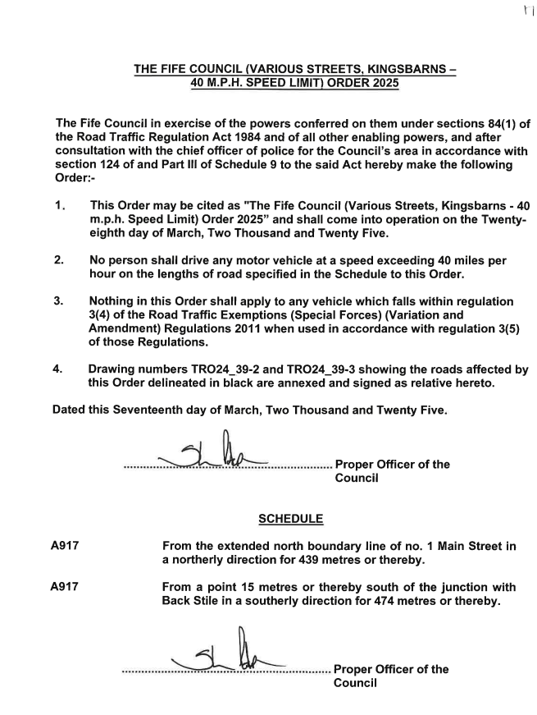

**Picture caption: Plans showing extents of 40mph speed limits.**

