Education Scrutiny Committee

18 March 2025

Agenda Item No. 6

|  |
| --- |
| Attendance Update Report March 2025 |
| Report by Angela Logue, Head of Service, Education and Children’s Services |
| Wards Affected: All |

Purpose

The purpose of this report is to give an update on the progress of attendance of children and young people in schools across Fife as requested by members at the [Meeting of Education Scrutiny Committee 7th May 202](https://www.fife.gov.uk/resources/download-document-sharepoint?siteId=b0a16c14-7250-44ae-86f0-8e50f76efb3c&listId=84f0c2e2-9406-43dc-b9c5-367fa62fed43&listItemId=82813)4, which included a comparison to the national attendance data provided by the Scottish Government in March 2024.

This report shares updated national attendance data in line with what has been published at the time of writing.

The report also outlines the ongoing work being carried out centrally and by all Fife schools to work to achieve this key priority, stated Fife Education’s Directorate Plan [ECS-Directorate-Improvement-Plan-2023-26](https://www.fife.gov.uk/__data/assets/pdf_file/0039/529986/ECS-Directorate-Improvement-Plan-2023-26.pdf)

Recommendation(s)

The Education Scrutiny Committee is asked to:

1. Scrutinise the attendance data and information provided.
2. Support the ongoing work both centrally and by schools in improving attendance.
3. Request a further progress report, proposed as March 2026.

Resource Implications

There are ongoing resource implications involved with the Management Information System (MIS) team centrally who produce the Power BI reports for schools on attendance and for schools in ensuring attendance across their work.

Legal & Risk Implications

There are no direct legal implications.

Impact Assessment

An EqIA has not been completed as this report does not propose a change to existing policies.

## Background, National and Local context

1. School absenteeism is a significant issue and challenge across Scotland’s schools with complex and wide-ranging underlying issues. Pupils’ attendance can be affected by many factors and a wide range of approaches are required from schools, families and partner agencies to promote and support children and young people’s attendance in school.
2. Research into pupil absence carried out by Fife Council’s Research & Insight Team in February 2024 identified many factors that can contribute to a child missing school, including poverty, seasonal variations, and family circumstances.
3. Factors that contribute to pupil absence were identified as:

* *Family circumstances*: Children with family issues such as bereavement or parental mental health issues have lower attendance.
* *Poverty*: Children in more deprived areas have higher absence levels.
* *Mental health*: Anxiety, low mood, and loneliness are common issues for children and young people.
* *Additional support needs*: Children with additional support needs related to learning or family and emotional issues have lower attendance.
* *Seasonal variation*: Attendance is seasonal, with a drop-off in December and a rise in January.
* *Parental attitudes*: Parental attitudes to school attendance have changed since the pandemic.
* *Other factors include*- Digital technology, Year group, Free school meals, Young Carers, Armed Forces children

1. Since the COVID pandemic there seems to have been a change in the mindset nationally on the importance of daily attendance of school (*Listening, and learning from, parents in the attendance crisis; Dr Sally Burtonshaw & Ed Dorrell; 2023*). Additionally, because of changed practices following the Covid Pandemic more people work at home now, which for some families creates a changed context enabling them to have their children at home without taking time off work.
2. The “Scottish Government Parent Club – Insight Gathering and Proposition Testing for School Attendance” 2024 research has sought to generate a greater understanding of the barriers and motivators for parents and pupils around school attendance. It recognises that issues behind absenteeism should not be over-simplified and can often overlap; accepting this they identified five key reasons for absenteeism, as listed below:
3. They identified that parents sometimes are content for their children to miss school because they perceive that there is something better for the children to do. This might include taking a more reasonably priced holiday during term time or another learning opportunity (e.g. a sporting event linked to a child’s interests).
4. The child dislikes school and sees no value in it (e.g. not useful, not for them). This was a reasonably common reason for not attending and appeared to align with parental views, sometimes from their own school experience.
5. In some circumstances children were absent due to a perception that the child does not fit into school, perhaps falling out with other children or feeling excluded by friend groups. The research named a key component of this as the power of 24-hour social media culture and saw potential triggers and associations with other issues such as mental health concerns.
6. The young person has an Additional Support Needs or needs support. This included a wide range of conditions and circumstances, which included children with undiagnosed and diagnosed conditions that required additional support, Young Carers and circumstances in the home/family environment which were felt to be valid/important by parent or carer.
7. Mental health issues were seen as a reason both as the cause or effect of absenteeism and were often a thread through reasons 2-4 above. The report observed that from talking with parents and children, through this project and others, that society is evolving, and mental health issues are increasingly and usefully recognised as being important and requiring care, putting a spotlight on feelings and mental health. The report also recognises the importance of balancing our understanding of mental health difficulties and dealing with natural challenges, sadnesses and anxieties we meet through life.

The research went on to describe what it referred to as a ‘spiral effect’ where the five reasons for missing school, important in their own right, can be a trigger, can overlap and compound each other, as children miss school, fall behind and lose connections with staff and peers in school.

The report went on to suggest barriers for parents in engaging with their children’s schools and approaches to addressing these barriers, which will be addressed through the partnership work next steps identified in Section Four of this report.

1. In Fife The Clued Up Project was commissioned to conduct research to add to our knowledge of the barriers affecting school attendance among young people and families in Fife. Given Clued Up’s strong relationships with vulnerable families and young people, the organisation was considered to be well-positioned to capture the perspectives of those whose views are at increased risk of being overlooked.
2. This research highlights the complex barriers affecting school attendance, with key themes around school systems, family and wellbeing. Through the report young people, families, and professionals have identified practical solutions, concluding that addressing the key issues with a trauma-informed and collaborative approach will be essential in improving school attendance and ensuring better outcomes for Children Young People and their families. An overview of some of the key issues, examples of approaches which were found to be working well and headline recommendations for improving attendance from the report is provided in Appendix One.
3. Children and young people with additional support needs (ASN) relating to learning (e.g. dyslexia) nationally, have attendance broadly in line with overall cohort. Pupils with ASN “More Able Learner” have attendance greater than the overall cohort.
4. There is a growing number of children with identified Additional Support Needs in Fife.

Figure One: Numbers of Fife pupils with noted ASN – 2019- 2024 (by needs)

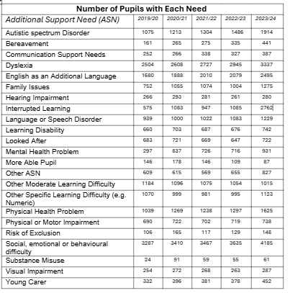

## 2.0 How are Fife schools performing in comparison to previous years, National Data, and Fife stretch targets?

1. Historically, attendance nationally was reported in detail every two years by the Scottish Government. Starting from 2023/24 it is being reported annually. A developing fortnightly updated national dashboard contains more limited information. Local Authority figures will be published end of March 2025.
2. The overall National attendance rate for 2023-2024 was 90.3%. This result is very similar to the previous year (90.2% in 2022-23) and continues to be below the attendance rates observed pre-Covid.
3. Fife overall attendance for last year 2023-24 was 89.6%. Like National, Fife’s attendance trend was similar to the previous year (89.5% in 2022-2023) and follows a period of steady decline. In absolute terms, the gap between Fife and National attendance was 0.7%.

Figure Two: Overall Pupil Attendance (Fife vs National) by session 2016-2024

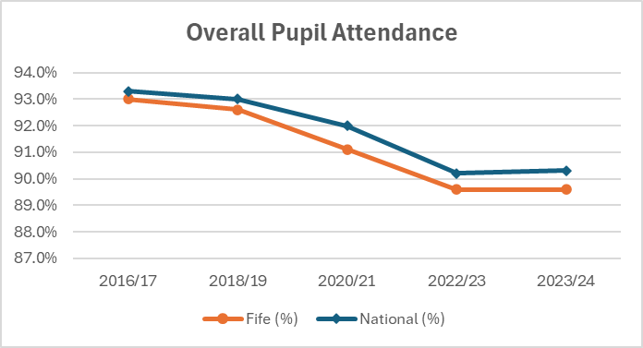

1. An attendance stretch target approach has been adopted by Fife Education Service to incrementally improve school attendance (adjusted to levels of deprivation). Attendance Stretch Aims projections are listed in Appendix Two with further detail provided in sections 2.10 - 2.11.
2. National Primary Sector Attendance was 92.5% in 2023-24. In the provisional Fife data submitted to the government, Fife Primary Sector 2023-24 attendance was 91.5%. This is similar to the previous year (91.3% in 2022-23).
3. Fife Secondary Sector 2023-24 attendance was 87.1%, which is similar to the previous year (87.3% in 2022-23).
4. Both nationally and in Fife, S2 and S3 are the lowest attending year groups. S3 in Fife is 85.1% and S4 is 87.2%. It should be noted that the current S3/S4 cohort transitioned from Primary to Secondary during Covid lockdowns. Some information about schools’ practice to support particular year groups is provided within Appendix Four.
5. All Scottish local authorities use an information system called SEEMiS to record attendance with codes which summarise the reason for absence. The use of codes can be complex, and consistency of coding relies on a number of different staff’s interpretation and application of coding. The MIS team have developed training for new admin coordinators to build consistency and confidence in this aspect of their role. We are also working to review and further define the range of codes used in SEEMiS, which aims to give improved definition to the reasons for absence.
6. Power BI is used by schools and Fife Education Directorate to monitor attendance patterns robustly. The MIS team have redesigned the Power BI attendance reports to give more comparison data and to make them available in a more timeous and responsive way. This has allowed for more forensic analysis of early declines in attendance at a school level and to target cohorts most effectively.
7. We began setting Stretch Attendance Targets for all of Fife Council schools last session (See Appendix Two). These are based on schools’ social context. The use of stretch targets is designed to provide focus for schools, to drive creativity and solution-focused approaches to securing improved attendance for pupils.
8. The attendance trajectory can be compared to the monthly stretch target projection shown in the graphs below. Attendance has a seasonal pattern (e.g. attendance tends to be higher at the beginning of each term and lower at the end of each term). The dashed line shows the 2024/25 projected attendance adjusted for seasonality. If monthly attendance reaches the projected stretch target every month, then the primary and secondary sector are projected to meet the Fife stretch target for 2024-2025 if the seasonal projections are accurate.

Figure Three: Primary Seasonal attendance Graph yearly comparison against stretch target

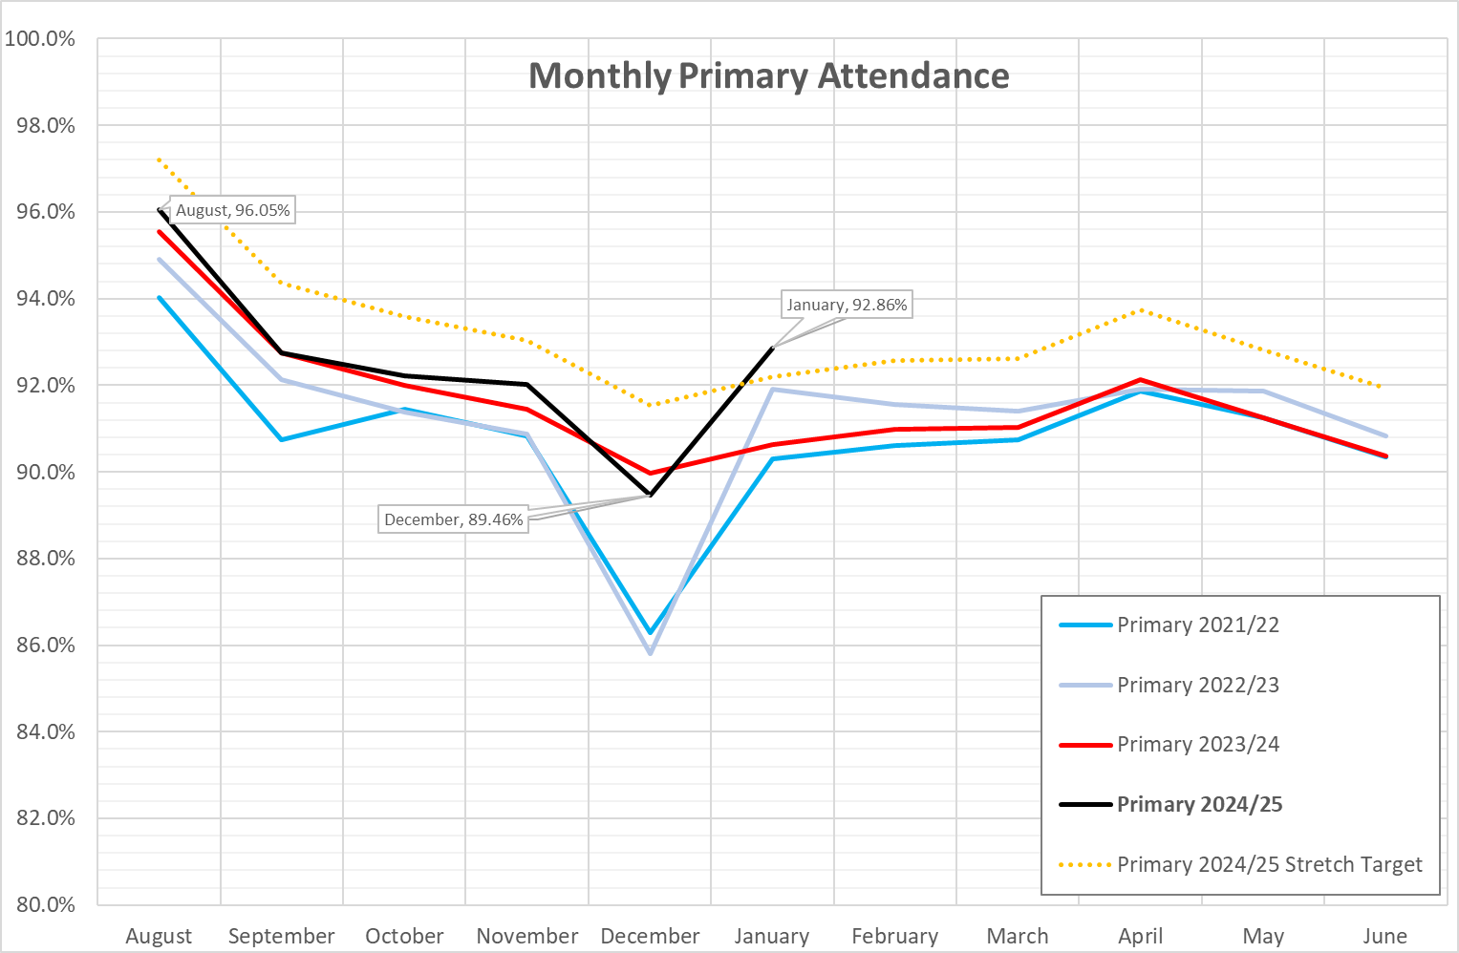

Figure Four: Secondary Seasonal Attendance Graph yearly comparison against stretch target

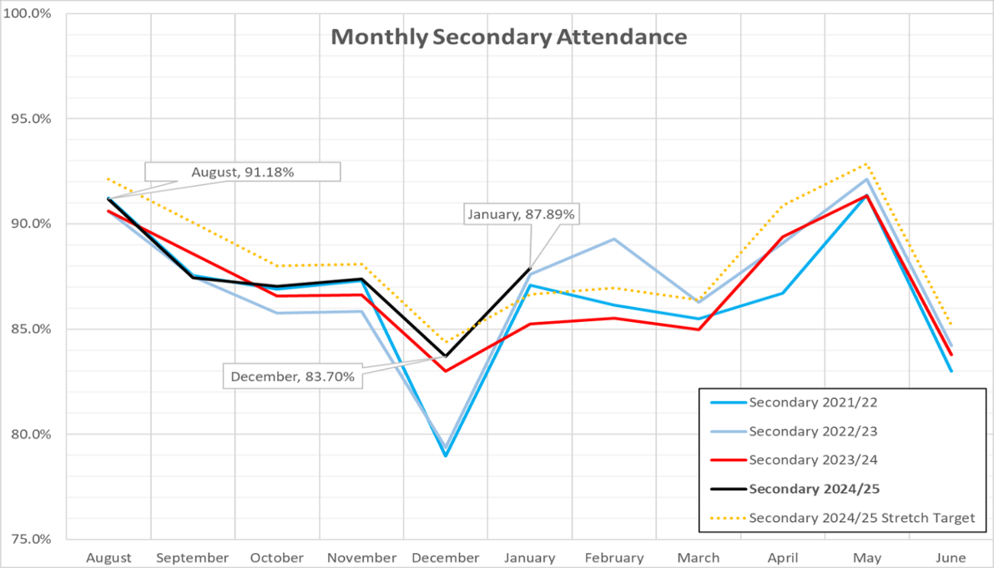

1. Average attendance of young people in the following categories are shown below. Analysis of specific groups shows that Free School Meals Registered (FSM) children & young people and Young Carers have the lowest attendance of all cohorts.

Figure Five: Average Attendance (%) Primary and Secondary Schools - 2023/24 for key categories

|  |  |  |  |  |  |  |  |  |
| --- | --- | --- | --- | --- | --- | --- | --- | --- |
| **All** | **FSM** | **Quintile 1** | **Quintile 5** | **LAC** | **ASN** | **Armed Forces** | **EAL** | **Young Carer** |
| **89.5%** | **82.7%** | **85.6%** | **93.1%** | **88.8%** | **85.7%** | **92.2%** | **88.5%** | **82.8%** |

Figure Six: Average Attendance (%) Primary Schools - 2023/24 for key categories

|  |  |  |  |  |  |  |  |  |
| --- | --- | --- | --- | --- | --- | --- | --- | --- |
| **All** | **FSM** | **Quintile 1** | **Quintile 5** | **LAC** | **ASN** | **Armed Forces** | **EAL** | **Young Carer** |
| **91.5%** | **85.6%** | **87.9%** | **94.5%** | **90.4%** | **88.9%** | **93.2%** | **89.1%** | **87.6%** |

Figure Seven: Average Attendance (%) Secondary Schools 2023/24 for key categories

|  |  |  |  |  |  |  |  |  |
| --- | --- | --- | --- | --- | --- | --- | --- | --- |
| **All** | **FSM** | **Quintile 1** | **Quintile 5** | **LAC** | **ASN** | **Armed Forces** | **EAL** | **Young Carer** |
| **87.1%** | **78.5%** | **82.4%** | **91.6%** | **87.1%** | **83.6%** | **90.8%** | **87.7%** | **81.2%** |

1. Armed Forces children and young people have the highest attendance overall of all identified cohorts at both primary and secondary level and remain at 2% above overall cohort.
2. The Fife attendance gap between Quintile1 and Quintile 5 remains at 7.5%. This is the same as the previous year. The National quintile gap reduced slightly from 6.7% to 6.6% due to lower Quintile 5 attendance results in 2023-24.
3. Most notably, Looked After Children and Young People in Fife had the biggest improvement in attendance overall compared to the previous year 88.8% (+1.2%), which is lower than 89.5% for overall cohort. This was mainly driven by 3.7% increase in Secondary sector attendance for this group. Care Experienced young people continue to be a focus of attention for Fife Council Education Service in line with the ambition of the Promise.
4. Young Carers had the second lowest attendance 82.8%, which was up 0.8% compared to the previous year, and have additional duties which schools need to be sensitive to. Schools have systems in place to avoid stigmatising young carers who may be late to school or absent due to caring responsibilities, as well as providing opportunities for additional study if required. Schools are encouraged to work closely with Young Carers in Fife, and to create and use Young Carer Statements to coordinate support the young carer.
5. For pupils with English as an Additional Language (EAL), the gap to the overall cohort is slightly larger in the Primary Sector (89.1% primary EAL vs 91.5% overall Primary cohort). In the Secondary sector the attendance in comparison to the overall cohort is 87.7% vs 87.1%. We are aware that this cohort may include young people who have significant trauma (for example those who have been displaced by conflict).
6. While pupils with ASN have attendance lower than the overall cohort (85.7%), stratification of ASN shows that attendance declines most significantly when there are family and emotional issues (e.g. bereavement, see ASN attendance by category diagram in section 2.20). Therefore, sensitive support for families and support for young people’s mental health, emotional issues and family support is required. Fife Education Service achieves this through nurturing approaches, trauma informed approach and with partner agencies to apply Fife’s wellbeing pathway. Further detail on enhanced support for transitions for ASN pupils, training for staff to support children with ASN and other supplementary information is provided in Appendix Three.
7. Pupils with ASN relating to family and emotional issues (substance abuse; family issues; young carers; mental health problems; bereavement and social, emotional, and behavioural difficulties) have lower attendance than the overall cohort. The six ASN categories relating to family and emotional issues have the lowest attendance shown in the graph below.

Figure Eight: ASN attendance by category (Fife)

1. Alongside the continuing work being done around chronic absence, including the use of nurturing approaches and a whole family multiagency approach to attendance of targeted pupils, like National, we have begun to see a decrease in the percentage of pupils with persistent absence for all sectors in 2023-24 (34.2%) compared to 2022-23 (34.7%). Persistent absentees are defined as absentees with 10% or more sessions missed. The gap between Fife and National percentage of persistent absentees missing 50% or more sessions continues to narrow. Fife is now nearly level (Fife 2.6% National 2.5%).

Figure Nine: Persistent Absences All Sectors (Primary, Secondary, Secondary) – 2010 – 2024

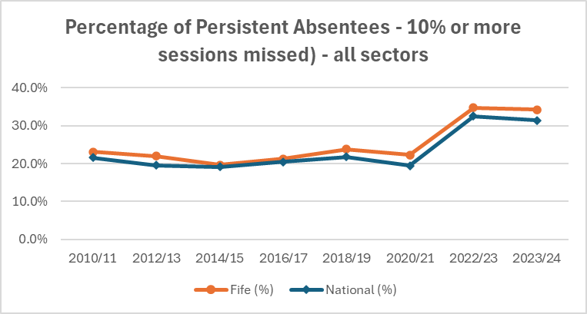

1. Authorised absence reduced overall in 2023-2024 (6.0%) compared to 2022-2023 (6.3%), and is now showing a further decrease this session (currently 5.69% - 19/2/2025) which is mostly due to seasonal authorised family holidays.
2. Unauthorised absence increased to 4.4% in 2023-2024, from 4.1% in 2022-2023, but has decreased to 4.17% - 20/2/2025 currently. An end-of-year analysis will determine if this is a continuing trend.

## 3.0 What are we doing to improve attendance in Fife?

1. We are working across four key, inter-related areas for improvement in Attendance and Engagement strategy work:
2. Implementation of high-quality policy and guidance to ensure we meet the needs of learners, families and schools.
3. Effective use of data
4. Effective strategies for improvement
5. Partnership work to support attendance and engagement
6. Implementation of high-quality policy and guidance to ensure we meet the needs of learners, families and schools:   
     
   **Attendance**
7. All schools and Early Learning Centres have access to broad, comprehensive guidance to support their practices in managing pupil absence and promoting attendance and to promote continuity of practice across Fife. This is updated frequently to take account of any new national guidance, learning from Fife quality improvement work or from feedback from our schools on impactful practices.
8. Examples of two schools’ practices in the application of the attendance guidance are provided in Appendix Four (Beath and Lochgelly High).
9. Education staff have tools within the guidance which support their reflection and evaluation of the approaches they take across their school around pupil attendance (see Attendance Assessment Self-Evaluation Toolkit in Appendix Five). This work is promoted and supported in a range of ways by central officers, such as:

* Attendance Audit Self Evaluations are completed by all Secondary Schools as part of their Outcomes review meetings
* Targeted support for individual primary schools

1. These actions help us to determine supports which might be offered to schools in terms of, for example, additional professional development opportunities. This contributes to ongoing quality improvement, building consistency of good practice.
2. We continue to promote schools’ use of Educational Psychology Attendance Assessment Toolkit (Appendix Six) to inform more targeted, effective planning for children in connection to school attendance and wider issues.   
     
   **Building Engagement:**
3. Building an effective curriculum is a key approach to growing pupil engagement. In Fife we have been working to develop and implement several initiatives to ensure that the curriculum children experience is relevant and engaging for all learners.
4. Part of this work has included the development of comprehensive progression pathways across all curricular areas, including newly completed pathways for Social Studies and Health and Wellbeing. These pathways provide clear guidance to practitioners, helping them identify learners' strengths and inform next steps in learning, integrating benchmark statements to establish a shared understanding of expected standards at each Curriculum for Excellence (CfE) level.
5. Additionally, we have focused on aligning the curriculum to support a smooth transition within the Broad General Education (BGE) from S1 to S3. This includes reviewing and enhancing the S1 to S3 curriculum to ensure it is engaging, appropriately challenging, and maintains a strong emphasis on pace and challenge. The impact of these initiatives is evident in the more coherent and consistent learning experiences provided to learners.
6. Looking ahead, we will continue to refine these progression pathways and encourage collaboration among educators to share effective practices. This will ensure that our pupils experience a curriculum that is dynamic and responsive to their evolving needs as learners.
7. These actions sit alongside national work underway to review and evolve Scotland’s curriculum.  
     
   **Meeting Learner Needs:**
8. We continue to implement Fife’s Additional Support for Learning Strategy. Schools have access to clear guidance and associated professional supports in relation to the use of core approaches to meeting needs and supporting wellbeing. This includes the CIRCLE framework, nurturing approaches, nurture hubs, trauma informed approaches) and poverty proofing of school day (including breakfast clubs).
9. In November 2024 guidance was produced to support pupils with ASN transferring into Fife or between Fife schools. This aims to ensure consistency of effective practice in meeting the educational needs of pupils who may require additional support, and applies to pupils of all ages, including pre-school children, who are:

* Moving into Fife with their family
* Moving into Fife as a looked after child
* Transferring school within Fife
* Transferring school within Fife as a looked after child
* Returning to Fife from residential school or another purchased placement
* Not resident in Fife but attending a Fife school

1. The aim is to provide a straightforward transition into Fife Council educational provision for children and young people, and to make the process clear and workable for parents/carers and placing agencies while managing accountability for resourcing.
2. We will work to develop a sustainable online learning offer for those disadvantaged by low attendance in Fife secondary schools. The purpose of this is to improve this group of young people's engagement with learning, their connection with their school and key staff within it, and to ensure that they have access to gaining qualifications and certification which will enable them to have post-school opportunities in line with their aspirations. Further information is provided in Appendix Seven.  
     
   **Effective Use of Data**
3. Schools across Fife hold a great deal of information relating to pupil attendance. This provides insight on individuals, classes and specific groups of learners, such as the groups outlined in the data shared in section 2.12. This data is available at school level through SEEMiS and an overview is also provided to all schools through Power BI.
4. A clear understanding of their pupils’ attendance issues enables schools to be successful in improving attendance and reducing persistent absence. Schools can identify trends within cohorts, such as reasons for absence or particular subjects where absence is high. This then enables them to identify and plan suitable, targeted approaches and interventions.
5. Monitoring and tracking of attendance by schools continues to be a focus and oversight data is analysed by officers and used to inform support and challenge to schools.   
     
   **Effective strategies for improvement**
6. A broad range of Quality Improvement (QI) Methodology work has been undertaken in Fife. The findings from this work are available to all schools through the Attendance guidance, as a source of information to them in planning their own approaches to improvement.
7. QI Work at Pathhead Primary School led the school to developing an approach which recognised the importance of a clearly defined role for each member of the school’s attendance team (the A-Team) who worked to make attendance a big priority. Data was seen as pivotal to’ keeping the machine running’ and effective communication between the team, children and parents was at the centre of the success. The team worked to make attendance a priority, to build positive relationships and to get to the heart of what the barriers were for families. This approach has impacted very positively on children’s attendance in the school. Further detail is provided in Appendix Eight

Figure Ten: Pathhead Primary School Pupil Attendance (2019 – current)

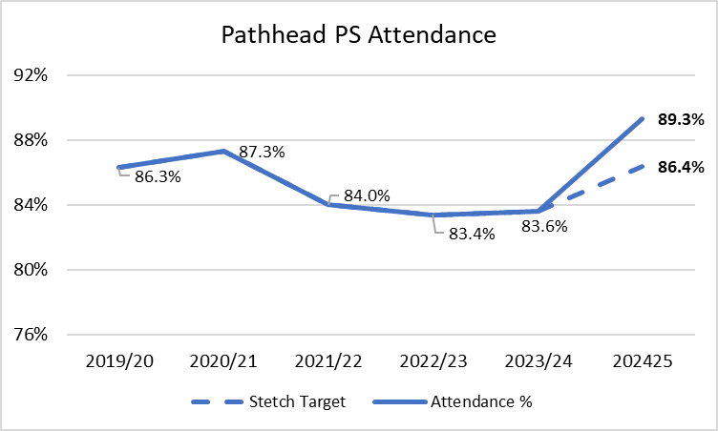

1. Fife’s Our Minds Matter framework and associated health and wellbeing improvement work relating to children and young people’s wellbeing is well-established in Fife currently this is focused on five key outcomes, further detail on this work can be found in Appendix Nine.
2. Children, young people and staff can seek help at an early stage when they are experiencing mental health problems, helping to reduce the stigma of mental health as a barrier to seeking support.
3. Raised awareness of the significance of physical wellbeing to our children, young people, their families and our staff, and improved access to key information, advice and support.
4. Promotion of positive relationships and behaviours between staff, children and young people in all educational settings.
5. Supported families to engage in positive wellbeing activities together considering universal and targeted approaches.
6. Communication and access to advice

**Partnership work to support attendance and engagement**

1. We continue to share information with parents about the importance of attendance at school and about our policies and approaches.
2. We promote the principle of ‘Attend to the End’ to families to help us to address seasonal variations in pupil attendance, particularly in the lead up to school holiday periods. (e.g. [Message for all our families - make the most of this term).](https://sway.cloud.microsoft/CVMxE7TzCOeaWWEG?ref=email)
3. A Case Study of the impacts of the Attend to the End approach for Madras College, St Andrews is provided in Appendix Ten.
4. Pupil Equity Funding is being used by many schools to fund the employment of Family Support Workers and other support staff to liaise directly with families to support re-engagement. This has shown to have a direct and positive impact on family and learner engagement and ultimately improved attendance.
5. Our Family Engagement Team of Family Support Workers and Pupil Support Officers are working with schools to support identified pupils from P6 to S3 and their families to re-engage with school. This is a limited resource, currently funded centrally from the Strategic Equity Funding, is having success in supporting re-engagement through supporting the wellbeing and mental health of young people and their families. Further information about this is provided in Appendix Eleven.
6. Fife’s Senior Practitioner Social Worker (SPSW) in schools model is within its second year of a two-year pilot. Within that time-period there has been five senior practitioner social workers based in five schools within Fife. This is an example of partnership working which has supported increased attendance for both individuals and cohorts of young people. Case Study Information about the **Social Work Senior** Practitioner Model in Levenmouth Academy is provided in Appendix Twelve

## 4.0 Next Steps and Conclusion

1. Attendance will continue to be a key focus in line with the Education Directorate improvement plan. Within this all schools will report upon their attendance data through their school’s annual Standards and Quality Report, which is shared on all school websites.
2. A wide range of next steps are identified within our four key areas for improvement in Attendance and Engagement strategic work. Implementation of high-quality policy and guidance to ensure we meet the needs of learners, families and schools:

* We will continue to maintain a focus on attendance across Fife Education and in every school and setting, ensuring good practice is shared through our headteacher updates and weekly bulletins and by updating our guidance with relevant information to support schools.
* We will continue to build consistency of good practice in supporting children, and their families at times of transition (e.g. Between Nursery and Primary, from stage to stage, when moving to/from a Home Educating arrangement, when joining a Fife school from a school out-with Fife, for children with Additional Support as needed) by producing overarching guidance.
* We will launch the Transforming Learning Strategy: 1-1 devices P6-S6, which includes an outcome relating to removing barriers that prevent the engagement of learners in education by addressing the equity of digital provision.

1. Effective Use of Data

* We will build upon the existing network of SEEMIS trained administrative staff to reflect upon the needs of school leaders to be involved in training and development.
* We will deliver a new Dashboard for Fife Education Directorate showcasing the key quality performance insights and indicators with high-level messaging based upon How Good is our Education Authority framework. This is to support Fife Education staff to ensure they are confident in their awareness and effective use of the data available on Attendance, Wellbeing, and Attainment.
* We will continue to develop our use of SEEMiS codes. This will include discussion with colleagues across Scotland on some of the variations which are apparent in how these codes are interpreted and applied.

1. Effective Strategies for Improvement

* We will continue to build upon prior Quality Improvement (QI) methodology practices connected to attendance by taking part in Education Scotland’s national Improving Attendance Quality Improvement Programme. We will centre this new project work on approaches to partnership with families in connection to improving attendance at school. Fife school staff from three High Schools, one Primary, Pupil Support Service and the Family Engagement team will take part in the programme. They will focus on testing changes, delivering results and sharing learning across Education to help us to deliver improvements in our practices in working with families to build attendance in school.
* We will continue to understand and learn from impactful practices used to improve attendance in other Local Authorities through involvement in Education Scotland’s Local Authority Attendance Leads group and our associated Local Authorities’ Quad Network.

1. Partnership work to support attendance and engagement:

* We will extend our focus on partnership working with families. We will work to develop a shared approach with families and other professional partners to promoting education and its goals, centred on a children’s rights-based approach. Alongside this we will extend the range of practices we use to communicate with families about attendance and their children’s engagement in school.
* We will consult with Fife Parent Councils on the introduction of four, area Parent Council Forums. These will aim to support our partnership with parents in Fife through awareness raising and consultation on key aspects for improvement within Education, alongside support for the function of Parent Councils.
* We will work with Children in Fife partner services to consider the links across Health and Wellbeing Work with Equity and Children’s Rights and Family partnership (to include Right to an Education, Goals of Education and Best Interests of the Child)

**Overview of Tables**

Figure One: Numbers of Fife pupils with noted ASN – 2019- 2024 (by needs)

Figure Two: Overall Pupil Attendance (Fife) by session 2016-2024

Figure Three: Primary Seasonal attendance Graph yearly comparison against stretch target

Figure Four: Secondary Seasonal Attendance Graph yearly comparison against stretch target

Figure Five: Average Attendance (%) Primary & Secondary Schools - 23/24 for key categories

Figure Six: Average Attendance (%) Primary Schools - 2023/24 for key categories

Figure Seven: Average Attendance (%) Secondary Schools 2023/24 for key categories

Figure Eight: ASN Attendance by Category (Fife)

Figure Nine: Persistent Absences All Sectors – 2010 – 2024

Figure Ten: Pathhead Primary School Pupil Attendance (2019 – current)

**List of Appendices**

1. Clued Up Research “Barriers to School Attendance in Fife”
2. Fife Attendance Stretch Targets
3. Additional Support Needs supplementary information
4. Schools’ Practice in applying Attendance guidance - examples from Beath and Lochgelly High Schools
5. Attendance Self Evaluation Toolkit
6. Educational Psychology Promoting Attendance Assessment Tool
7. Online Offer for those disadvantaged by low attendance (Secondary)
8. Quality Improvement Work Exemplar - Pathhead Primary
9. Health and Wellbeing Improvement Overview
10. Case Study Impacts – Attend to the End Madras College
11. Family Engagement Team
12. Senior Practitioner Social Worker (SPSW) Model – Levenmouth Academy

#### Background Papers

The following papers were relied upon in the preparation of this report:

[School-attendance-literature-review-final - Adobe cloud storage](https://acrobat.adobe.com/id/urn:aaid:sc:EU:0da3372c-5c5c-4f5d-83c3-3d7cd73ad4d9)

Education and Children’s Services Directorate Improvement Plan 2023-26

[ECS-Directorate-Improvement-Plan-2023-26](https://www.fife.gov.uk/__data/assets/pdf_file/0039/529986/ECS-Directorate-Improvement-Plan-2023-26.pdf)

Fife ASL Strategy <https://www.fife.gov.uk/__data/assets/word_doc/0037/567199/ASL_Strategy_2023-26.docx>

Education Scotland document: *Engaging parents and families to improve Attendance in School”* (Draft title) Due to be published March/April 2025. This contains insights from Scottish Government’s: Parent Club – Insight Gathering and Proposition Testing for School Attendance, Research carried out in 2024

#### Report Contacts

Rona Weir

Education Manager

Education and Children’s Services

Fife House

North Street

Glenrothes, KY7 5LT

Rona.weir@fife.gov.uk

**Appendix One -**

**Clued Up Research “Barriers to School Attendance in Fife”**

**Methodology:**

During the initial research phase, 20 CYP participated in one-to-one interviews utilising quality improvement tools, such as cause and effect diagrams, to identify factors contributing to their barriers to attendance. Of the 20 participants, 13 were already engaged with Clued Up, and 7 were receiving support from other services. To broaden the scope of engagement, researchers facilitated focus groups and group interviews with additional Children and Young People (CYP) and their families, including 5 CYP from Fife Young Carers, 8 CYP from the P7 transition service, and 8 parents/guardians from Fife Gingerbread’s parents' group.

*Key themes identified by YP*

1. Language and Lack of Understanding When staff are unaware of students' circumstances, or presume every student has a ‘normal’ life, seemingly small remarks can have a deep impact, reinforcing feelings of school feeling like an unsafe space.

2. Stigma Stigma was a very common factor throughout the interviews, many CYP explained that they felt like they were stigmatised either by attitudes to their family background or to previous choices they had made. The report explains that this perception of being unfairly categorised discourages YP from engaging in school, as they feel they have no chance at having their own identity.

3. Inconsistency Amongst Staff YP reported differences in teachers’ approaches. YP felt that while some staff demonstrate empathy and understanding, others contribute to stress and anxiety.

4. Environment Many YP highlighted concerns about the physical and social environment within school buildings, particularly in larger schools. They expressed that schools often feel too big, crowded, and overstimulating, with limited access to safe spaces where they can regulate their emotions when feeling triggered or overwhelmed. Additionally, YP found lunch, break times, and class transitions especially overwhelming.

*Examples were provided of approaches which were working well under the following headings*:

* Separate Learning Provisions: Many schools were noted to adopt the approach of having a separate learning community building, which YP found beneficial. This provided an environment where they could catch up on learning gaps, receive support for anxiety, and build peer relationships. The small, nurturing setting allowed for more one-on-one support and smaller groups, increasing attendance by offering an alternative solution. Most learning centres also offered practical learning opportunities such as cooking and walking which engaged CYPs in another way. One limitation of this approach however was often YP can feel quite isolated from mainstream education, and it can also take a long time to reintegrate them back in.
* Innovative Attendance Interventions: One positive piece of feedback came when CYP were included in innovative ways to raise attendance using peer support models. An example of this was an initiative led by Active Schools in collaboration with a Community Social Worker. They organised Muay Thai lessons for YP who were struggling with attendance and community-related issues. Participants included a group of boys who weren’t attending classes and were smoking weed together instead, further discouraging attendance. By forming a peer-support model, these YP encouraged each other to participate in the group, which ultimately facilitated re-engagement with education in a fun and proactive way whilst building relationships with school staff.
* Another successful initiative involved Clued Up, where YP participated in learning provisions outside of traditional school settings, such as the learning annex. However, they weren’t attending due to anxiety of a new building. YP were grouped together and took part in group work with Clued Up in the annex before there session was to start, to ensure they could build a routine of attending the annex at the right time, use peer support to encourage each other to go and to reduce anxiety of a new building. After this group, the group of six boys who attended left with all five qualifications when they were on track to leave with none.
* Primary Seven Transition Service: School transitions emerged as a major theme influencing attendance. In response, Clued Up introduced a P7 enhanced transition service in the Levenmouth area to support YP and their families. A research project conducted with The Collective found that after engaging with the Clued Up P7 transition service, only 8% of YP reported a negative transition and attendance difficulties, whereas all YP who didn’t receive support until after primary at Clued Up, reported a negative transition. This was done through 1-1 support and groupwork in the school, helping them familiarise themselves with the school building and school staff members.
* A principal teacher shared: *“[Child] was identified for support at the start of P7. In P6, [they] only attended a few days in Term 4, so we aimed for a positive start in P7. [Staff] played a huge role in making this happen. [They] ensured [child] attended as planned and even looked forward to their time with [staff]. The time invested in [child] and their family was invaluable. [Staff] became a trusted ally for [child] and the school, making their P7 experience significantly more successful than it might have been otherwise*.”
* Community Engagement and Partnership with Education: The report shared that some schools excelled in engaging with community partners, with Levenmouth Academy standing out due to its collaboration with third-sector agencies. These partnerships provided essential support to YP outside of school, addressing underlying issues and subsequently improving attendance. The presence of these partners strengthened professional relationships, which increased referrals to services – providing more support to CYP and their families. One challenge, however, was ensuring sufficient space within schools to accommodate community partners while maintaining confidentiality. Furthermore, multiple community partners contributed to enhancing learning opportunities through practical work experiences. Initiatives such as community trade hubs, Clued Up, Fife Young Carers, Kingdom Off Road, and Nurture groups provided alternative pathways for education. However, some YP expressed these opportunities appear to be too late in high school, often more opportunities being available after 3rd year which CYP felt was too late.
* Additionally, some areas particularly Levenmouth, were better at linking with community partners, presenting gaps in other areas. Another significant factor found to support attendance was the effectiveness of multi-agency collaboration within education and the community. One mentionable initiative in the Levenmouth/Kirkcaldy area focused on families impacted by substance use – Making it Work for Families (MIWF). The project brought together: Fife Gingerbread – Supporting parents and family relationships FIRST – providing rehabilitation support to parents Clued Up – providing youth development support CARF – Providing financial maximisation Although these are different organisations, they function as one team to provide a trauma-informed service to families impacted by substance use This approach ensured that families did not need to repeatedly share their stories with multiple professionals. Each family member had a dedicated worker, an approach used to build trusting relationships in a 1-1 setting but in a coordinated way to ensure family development and support also. Moreover, it is important to mention that this support was consistent and time-unlimited but focusing on progression. Additionally, the team worked closely with education and social work services to address attendance barriers and enhance family outcomes. By providing timely interventions services like MIWF significantly contributed to improving YP’s school engagement

*The report’s recommendations for improvement included:*

* Use of Trauma Informed Approach
* Effective Relationships and Behaviour Strategies within Schools
* Children and Young People feeling supported and free from stigma
* Early Identification of Early Warning Signs and Acting in a Timely Manner
* Practical Learning Opportunities
* Schools Aware of Important Information that aids understanding
* Consistency amongst guidance staff, using a relationship-based approach
* Effective Communication or relationships between parents and Education
* Effective preparation for High School during primary and positive transition

**Appendix Two -**

**Fife Education Service Stretch Aims**

**Core stretch aim (e): wellbeing – primary attendance**

|  |  |  |  |  |  |  |  |  |  |  |  |  |  |
| --- | --- | --- | --- | --- | --- | --- | --- | --- | --- | --- | --- | --- | --- |
| **Annual Trajectory** |  | **2022/23** | | |  | **2023/24** | | | | |  | **Stretch target** | |
|  |  | **Fife** | **Scotland** | **Gap vs Scotland** |  | **Fife** | **Scotland** | **Gap vs Scotland** | **Stretch target** | **Gap vs target** |  | **2024/25** | **2025/26** |
| Overall level |  | 91.3 | 92.2 | -0.9 |  | **91.5** | 92.5 | -1.0 | **92.2** | -0.7 |  | **93.1** | **94.0** |
| SIMD Quintile 1 |  | 88.0 | 89.1 | -1.1 |  | **88.0** | 89.6 | -1.6 | **89.4** | -1.4 |  | **90.7** | **92.5** |
| SIMD Quintile 5 |  | 94.3 | 94.8 | -0.5 |  | **94.5** | 95.0 | -0.5 | **95.0** | -0.5 |  | **95.5** | **95.5** |
| Gap (Q1 to Q5) |  | 6.3 | 5.7 | 0.6 |  | **6.5** | 5.5 | 1.1 | **5.6** | 0.9 |  | **4.8** | **3.0** |

**Core stretch aim (e): wellbeing – secondary attendance**

|  |  |  |  |  |  |  |  |  |  |  |  |  |  |
| --- | --- | --- | --- | --- | --- | --- | --- | --- | --- | --- | --- | --- | --- |
| **Annual Trajectory** |  | **2022/23** | | |  | **2023/24** | | | | |  | **2024/25** | **2025/26** |
|  |  | **Fife** | **Scotland** | **Gap vs Scotland** |  | **Fife** | **Scotland** | **Gap vs Scotland** | **Stretch target** | **Gap vs target** |  | **Stretch target** | |
| Overall level |  | 87.3 | 87.7 | -0.4 |  | **87.1** | 87.6 | -0.5 | **88.3** | -1.2 |  | **89.5** | **90.7** |
| SIMD Quintile 1 |  | 82.0 | 83.7 | -1.7 |  | **82.1** | 83.5 | -1.4 | **84.6** | -2.5 |  | **86.5** | **88.4** |
| SIMD Quintile 5 |  | 91.4 | 91.8 | -0.4 |  | **91.4** | 91.8 | -0.4 | **92.0** | -0.6 |  | **92.5** | **93.0** |
| Gap (Q1 to Q5) |  | 9.4 | 8.1 | 1.3 |  | **9.3** | 8.4 | 0.9 | **7.4** | 1.9 |  | **6.0** | **4.6** |

**Appendix Three -**

**Additional Support Needs Supplementary Information**

**Procedures and timelines put in place prior to welcome a child with identified ASN to a school:**

Enhanced transition is planned with the team around the child and procedures and timelines are individualised. For children with a recognised Visual Impairment or Hearing loss the planned transition into education starts pre-nursery through attendance by education staff at NHS clinics. For other children with a recognised need at Early Level, Health Visitor and Educational Home Visiting service support this process. Between nursery and primary and primary and secondary this can be planned for up to two years prior to transition being made. Within an educational establishment between stages then enhance transition may be planned for up to a few months prior to changes.

In the secondary sector, again transition planning for a child/young person with additional support needs, can take place from P6 onwards and this would be part of a bespoke transition package. Up until 2022, the decision on a C/YP who could be placed in a high school’s department of additional support (DAS), was taken by the West Fife, Central or North East Fife Area Management Group (AMG). Since 2023, however, decisions have been made more locally, with each high school having a ‘cluster forum’ meeting, involving all feeder primary schools and EPs. Transition planning is discussed here between schools to ensure that the transition package is appropriate. In most cases, transition planning is already underway by this point, as the cluster forum takes place annually each December, to confirm placements for C/YP who would start in high school the following August.

**Professional Development Supports for Education staff working with ASN children:**

Professional learning is provided by Fife Education Directorate’s Support for Learners Service, the Professional Learning Team and Educational Psychologists. The programme of professional learning is reviewed and refreshed yearly from feedback gathered from colleagues and from data gathered and analysed.

All mainstream class teachers, as part of General Teaching Standards (2021), have a professional responsibility to continue to develop their expertise and experience across all areas of their professional practice through appropriate and sustained career-long professional learning.

*As a registered teacher you are required to demonstrate a depth of knowledge and understanding of the stages of learners’ cognitive, mental, social, emotional, physical, and psychological development and know how to use this information to support learning and wellbeing; use digital technologies to support learning;  plan coherent, progressive and engaging teaching programmes which address the needs of every learner; identify the potential barriers to learning and plan differentiated and appropriately challenging learning experiences to ensure learning is accessible for every learner; communicate appropriately with every learner, modelling and promoting competence and confidence in literacy, numeracy, health and wellbeing and digital literacy; ensure teaching builds confidence and promotes the progress of every learner; and plan learning that is creative, sustainable and uses available resources.*

**Number of children with identified and supported ASN currently attend Fife Nursery and Primary Schools and resources to help meet these needs:**



Each school updates individual pupil records on SEEMIS to identify additional support needs.

*Percentages of Children within each sector with identified ASN (Fife)*

We have a range of resources at school level, to meet needs for example:

1. *Mainstream establishments:*

Pupil Support hours allocation,

Support for Learning Teacher allocation,

Pupil Equity Funding to support identified individuals or cohorts,

Support for Learners Service which provides support in a variety of ways through outreach and professional learning (e.g. Autism, Visual Impaired, English as a Second Language, Visual Impaired, Pupil Support Service who provide both in reach and outreach).

1. *All schools have a link Educational Psychologist*
2. *Primary Additional Support Needs classes*

Currently eight and currently under consultation to increase to ten

1. *Secondary Schools*

18 Department of Additional Support Needs

1. *Intensive Provisions:*

Five special schools

**Number of Fife children with noted ASN across primary and secondary schools who are subject to a Co-ordinated Support Plan (as distinct from a Child’s Plan or an Individual Education Plan):**

|  |  |
| --- | --- |
| Primary School | 9 |
| Secondary School | 10 |
| Special School | 6 |

There are national standards for the creation of a CSP, whereby defined criteria have to be met. Schools will work with parents, Educational Psychology and other professionals/agencies as appropriate to identify the need for a CSP and meet the timescales for implementation and review.  In Fife we apply these standards to reflect Government guidelines and expectations.

**Appendix Four-**

**Attendance guidance practice application examples from Beath and Lochgelly High Schools**

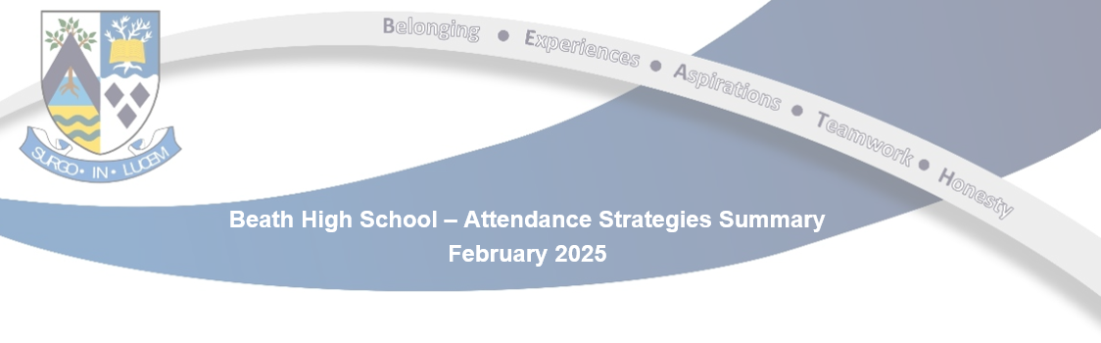

**Key strategies for improving attendance**

* Two Principal Teachers in post with Improving Attendance remit (PEF funded).
* Change to Guidance Remits to create attendance link responsibility with PT Improving Attendance (2 Guidance Houses each).
* Engage parent/carers of young people with 90% or less attendance. Focus is on early intervention. **Monthly** alerts are sent home when attendance dips below 90% (informed by **monthly** SEEMiS report generated by clerical staff in the school office).
* Engage with parents/carers on a **weekly** basis regarding any unexplained absences/concerns (informed by **weekly** SEEMiS reports generated by Guidance Clerical in the Guidance Hub).
* Engage with parents/carers on a **daily** basis regarding any unexplained absences for two or more periods of the day (informed by **daily** report generated by clerical staff in the school office).
* **Daily** attendance reports sent to all staff
* **Daily** attendance reports sent to Guidance and Attendance PTs broken down by Registration Group.
* Explicit link made between attendance procedures and Child Protection in staff safeguarding presentations. Explicit link to how improved attendance links to increased attainment for pupil assemblies and parent/carer presentations.
* Pupil Support Officer (PSO) support and monitoring of corridors to return pupils back to class.
* Blue attendance sheets are used by PT Improving Attendance to monitor attendance following issues/as discussed with home.
* Sustained focus on attendance and late-coming – especially for the most vulnerable YP.
* PTs Improving Attendance are present in pupil social areas at the start of the school day to meet/greet and build positive relationships.
* The school works to involve parents/carers and young people in its Attendance Working Group.
* Continuous (**daily**) reviews of absence coding of pupils on SEEMiS.



Lochgelly High School has a number of strategies to support learners in maintaining positive school attendance. Universally, these include:

* Monthly tracker shared with all PTs and Senior Leaders to allow comparison between overall school and in-class attendance
* Recorded interventions by the Guidance team, with concerns raised weekly at House meetings
* Clarity of the role of teaching staff provided by the attendance policy
* DIPs aligned with the school’s Improvement Plan, outlining steps at departmental level to encourage positive attendance and address developing patterns of decline
* Continued work from the Attendance Support Worker (PEF) who makes (approx.) 10 home visits per week to those most at risk of non-engagement

For S3 and S4 learners in particular, there are a number of targeted supports. This includes a growing alternative curriculum, delivered both in-house and through partner agencies, to ensure the school works to maintain enjoyment and personalisation and choice within its offering. This is supplemented further with the now embedded School of Football and (in S1 and S2), the School of Rugby. These have brought about notable improvements in attendance for targeted participants.

Within S4 the school has a carefully monitored number of Agreed Reduced Attendance (ARA) Plans in place, which build in some flexibility for learners who need it. This flexibility has allowed, in the majority of cases, previously disengaged learners to begin re-attending school; either for parts of the normal school day or by attending our after-school provision. This engagement has not only brought about some improvements in attendance but is also supporting the school’s drive for 100% 5@3.

**Appendix Five-**

**School Attendance Self-Evaluation Toolkit**

|  |  |  |  |  |  |
| --- | --- | --- | --- | --- | --- |
| **HGIOS (4) Category** | **QI** | **Reflective Statements** | **What are the current strengths in this area?**  (Evaluative statements based upon impact upon learners) | **What key evidence do you have of improvement in this area?**  (Triangulation of evidence: Views / Observation / Data) | **What are we going to do now?** |
| **Leadership & Management** | 1.1 | Through ongoing self-evaluation we understand attendance patterns in our school. |  |  |  |
| 1.1 | We systematically gather data to monitor and track the attendance of individual children / young people. |  |  |  |
| 1.2 | Our staff routinely engage in career-long professional learning (CLPL) to understand key guidance such as GIRFEC and the UNCRC and how this relates to school attendance and the right to an education. |  |  |  |
| 1.1 | We are guided by local and national policies, guidance and legislation around school attendance and a child’s right to an education. |  |  |  |
| **HGIOS (4) Category** | **QI** | **Reflective Statements** | **What are the current strengths in this area?**  (Evaluative statements based upon impact upon learners) | **What key evidence do you have of improvement in this area?**  (Triangulation of evidence: People’s views / Observation / Data) | **What are we going to do now?** |
| **Learning Provision** | 2.1 | We have clear policies and procedures in relation to child protection and safeguarding and all staff understand the importance of attendance in relation to keeping children and young people safe. |  |  |  |
| 2.1 | Children and young people have a named education contact with whom they discuss any personal issues or concerns which may impact on their attendance. |  |  |  |

|  |  |  |  |  |  |
| --- | --- | --- | --- | --- | --- |
| **Learning Provision** | **QI** | **Reflective Statements** | **What are the current strengths in this area?**  (Evaluative statements based upon impact upon learners) | **What key evidence do you have of improvement?**  (Triangulation of evidence: Views / Observation / Data) | **What are we going to do now?** |
| 2.1 | Children and young people feel safe in school. There are a variety of supports for them such as buddying and safe havens. We evaluate the impact of these supports. |  |  |  |
| 2.2 | Our curriculum design supports the engagement of children and young people. |  |  |  |
| 2.2 | We have flexible learner pathways building on key curriculum design principles such as personalisation and choice, challenge and enjoyment and relevance to encourage good attendance. |  |  |  |
| 2.2 | We work with partners to develop bespoke curricular approaches for children / young people at risk of not attending. |  |  |  |
| 2.3 | Our school culture reflects an ethos of Children’s Rights and positive relationships and this encourages children / young people’s attendance at school. |  |  |  |
| 2.4 | All children and young people benefit from high-quality universal support which engages them in their learning. |  |  |  |
| 2.4 | We understand that poor attendance is a factor giving rise to additional support needs. We use the Child’s Planning Framework to support good attendance. |  |  |  |
| 2.4 | We are proactive at responding to the needs of our most vulnerable children / young people including those with care experience and in poverty. We minimise their barriers to good school attendance. |  |  |  |

|  |  |  |  |  |  |
| --- | --- | --- | --- | --- | --- |
| **Learning Provision** | **QI** | **Reflective Statements** | **What are the current strengths in this area?**  (Evaluative statements based upon impact upon learners) | **What key evidence do you have of improvement?**  (Triangulation of evidence: Views / Observation / Data) | **What are we going to do now?** |
| 2.5 | We promote family learning for all of the families in our school community to bridge the gap between home and school. |  |  |  |
| 2.5 | Where appropriate, we work with and signpost families to services which support good school attendance. |  |  |  |
| 2.6 | We plan transitions carefully to ensure that children and young people and their families are fully supported and that key information is shared. This allows us to intervene early when attendance is of concern. |  |  |  |
| **HGIOS (4) Category** | **QI** | **Reflective Statements** | **What are the current strengths in this area?**  (Evaluative statements based upon impact upon learners) | **What key evidence do you have of improvement?**  (Triangulation of evidence: Views / Observation / Data) | **What are we going to do now?** |
| **Successes and Achievements** | 3.1 | We can evidence wellbeing entitlements for all of our children and young people. We use local and national policies, guidance and legislation to support us with this. |  |  |  |
| 3.1 | We have evidence to demonstrate that the steps we have taken to improve the attendance of individuals has had a positive impact. |  |  |  |
| 3.1 | We celebrate diversity and challenge all forms of discrimination to create an inclusive learning environment. |  |  |  |
| 3.3 | Children and young people have the opportunity to connect their learning and acquisition of skills to the world of work in order that they can appreciate the relevance of their learning opportunities. |  |  |  |

|  |  |  |  |  |  |
| --- | --- | --- | --- | --- | --- |
| **Successes and Achievements** | **QI** | **Reflective Statements** | **What are the current strengths in this area?**  (Evaluative statements based upon impact upon learners) | **What key evidence do you have of improvement?**  (Triangulation of evidence: Views / Observation / Data) | **What are we going to do now?** |
| 3.2 | We ensure that the provision of part-time timetables is used only when necessary, is recorded appropriately and reviewed at regular intervals. |  |  |  |
| 3.2 | We provide suitable learning resources for children and young people who cannot attend school and check in with them regularly. |  |  |  |
| 3.2 | We make regular contact with home for children and young people who are not attending or have poor school attendance and ensure we regularly review the child’s planning framework that is in place for them. |  |  |  |

**Appendix Six-**

**Educational Psychology Promoting Attendance Assessment Tool**

**Appendix Seven –**

**Online Offer for those disadvantaged by low attendance (Secondary)**

In August 2025 a working group was set up by Vivienne Sutherland, Principal Psychologist, to lead the work on developing a sustainable online learning offer for those disadvantaged by low attendance in Fife secondary schools.

The purpose of this is to improve this group of young people's engagement with learning, their connection with their school and key staff within it, and to ensure that they have access to gaining qualifications and certification which will enable them to have post-school opportunities in line with their aspirations. The work supports the Directorate Priorities as outlined in the Education Service Improvement Plan 2023-26, specifically **Priority 2: Improving Attendance and Engagement** and **Priority 3: Achievement,** and through this support the cross-cutting theme of **Equity and Equality** through its focus on those learners disadvantaged by low attendance

A range of secondary school staff, including members of senior leadership teams, Principal teachers, subject specialists and Guidance/Support for Learning staff volunteered to participate, alongside partners from the Family Support Service. The work of the group was informed by research carried out previously with secondary staff by the Educational Psychology Service.

The key tasks identified by the group are to:

1. Build a bank of curricular resources, which is accessible to all secondary schools and can be targeted for young people and families
2. Problem-solve the accessibility of technology and materials for young people learning online from home
3. Plan for how best to engage the targeted group of young people, including assessment of wellbeing needs and any barriers to learning which need to be taken into account

The key principle of the work is to build on good examples of what is already working in our secondary schools, using some of the learning and online curriculum developed and delivered during lockdown, and to build a platform of online materials to which all schools will contribute and to which all schools will have access. Access to national learning resources such as E-sgoil will also be included. This will help us design a model from which all Fife schools can benefit.

We would plan to use the learning from this to develop a similar offer for Fife primary schools, in due course.

**Appendix Eight - Quality Improvement Work Exemplar - Pathhead Primary**

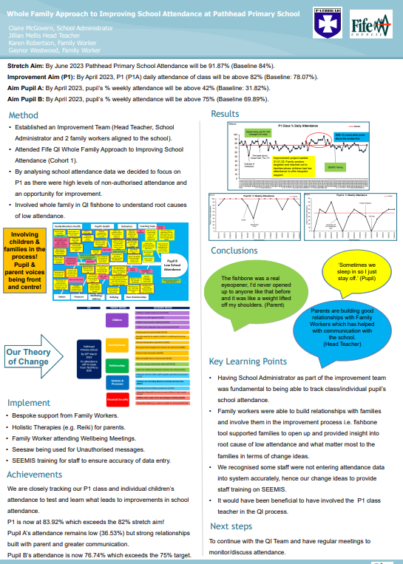

**Appendix Nine -**

**Our Minds Matter and Associated Health and Wellbeing Development Overview**

**Overview of Health & Wellbeing Improvements**

*Across Five Key Outcomes:*

1. Children, young people and staff can seek help at an early stage when they are experiencing mental health problems, helping to reduce the stigma of mental health as a barrier to seeking support.
2. Raised awareness of the significance of physical wellbeing to our children, young people, their families and our staff, and improved access to key information, advice and support.
3. Promotion of positive relationships and behaviours between staff, children and young people in all educational settings.
4. Supported families to engage in positive wellbeing activities together considering universal and targeted approaches.
5. Communication and access to advice

*Outcome One:* Children, young people and staff can seek help at an early stage when they are experiencing mental health problems, helping to reduce the stigma of mental health as a barrier to seeking support.

|  |  |
| --- | --- |
| **Actions Include:**    **Decider Skills**  Roll out Decider Skills into Fife primary schools as a universal approach for CYP and their families.    **Education Referral Pathway for Mental Health and Wellbeing Supports and Services**  Develop and pilot a pathway to support access to mental health and wellbeing support for all school aged children and young people (Initially piloted for secondary aged young people) who are registered with a Fife school and require additional support for their mental health and wellbeing.    **Commissioning**  Conduct a needs analysis of mental health and wellbeing needs of children, young people and families and consider gaps in provision to inform the next round of commissioning.    **Access to Support**  Implement a referral system using the wellbeing pathway in schools, providing access to community mental health provisions for children and young people    **Bereavement Support**  Improved access to support for bereaved children, young people, families and staff, and improved knowledge and confidence of staff to support bereaved children and young people.    **Pupil-Led Initiatives**  Increase opportunities for young people to lead on mental health initiatives including the continued roll-out of See Me See Change programme across secondary schools to encourage pupils, staff and the wider school community to develop and initiate actions to address mental health stigma and discrimination.    **Staff Wellbeing**  Improve access to Fife Council’s Employee Assistance Programme (EAP) through increased awareness and understanding  Identify gaps in EAP provision and explore opportunities to provide additionality through the commissioning of services for staff  Increase participation in Mentally Healthy Workplaces training across all sectors and services  Connect Staff from across the network to collaborate and develop approaches |  |

*Outcome Two* -Raised awareness of the significance of physical wellbeing to our children, young people, their families and our staff, and improved access to key information, advice and support.

|  |  |
| --- | --- |
| **Actions include:**     * Active Schools Core Offering to be embedded within all 18 clusters, with particular focus on bridge programming by providing additional support to CYP who are disadvantaged and / or vulnerable with referral processes * Integrating monitoring & evaluation practice across Active Schools programmes to ensure reporting / evidencing impact is relevant and purposeful to service / directorate outcomes * Improved communication and awareness raising mechanisms to be developed for internal & external purposes. * Ensure education staff are aware of the opportunities to engage in PA opportunities within communities as part of their own wellbeing * (C) Resource Sharing Platform – Link resources to enable YP to access in an effective way. |  |
|  |

Outcome Three: Promotion of positive relationships and behaviours between staff, children and young people in all educational settings.

|  |  |
| --- | --- |
| **Actions include:**     * Through further consultation and focus group activities, identify solutions to specific improvement priorities highlighted in the Staffwise results reports of the lowest scoring sectors / areas of the Directorate, in addition to the key themes from the Head of Service led HWB sessions * Support Core Approaches (Trauma Informed/De-escalation). A 4-area Network Model: 3 twilights across the year for teams to collaborate & share practice around their priority theme. These will be led by school-based facilitators. * Deliver a range of PL programmes around positive relationships: * In person: 6-part Positive Relationships for Learning * Self-led: Staff Wellbeing, 6 Principles of Nurture, Trauma Informed Practice, De-escalation * Improve support for school leaders across all sectors and provide additional support for those directly involved in child protection work by implementing the 'Effective Supervision for School Leaders' proposal * Progress the Education Directorate priority areas of Culture and Behaviours and Leadership and Management from the Our People Matter action plan * Align the priorities of the Education Directorate Our People Matter action plan with our own Health and Wellbeing reporting mechanisms to ensure more coordinated delivery and a better understanding of the impact * Work to develop a QI approach to Staff wellbeing * Gender Based Violence – Ensure all 18 secondary schools are supported to deliver Mentors in Violence Prevention (MVP) programme and encouraged to engage with Equally Safe at School (ESAS). Increased opportunities for pupil accreditation and involvement in community activities, and improved methods for measuring impact and progress made. |  |
|  |

*Outcome Four*: Supported families to engage in positive wellbeing activities together considering universal and targeted approaches.

|  |  |
| --- | --- |
| **Actions include**     * Core Personal Social Education (PSE) promoted and supported within all High Schools including transition from Primary     **Decider Skills**   * Train a group of community-based facilitators: parents and carers, group leaders to facilitate peer groups for families within the community     **Emotional Regulation**   * Provide opportunities for families to develop their knowledge and confidence in supporting the emotional wellbeing of their child of young person. * Sport & physical activity related family engagement programmes to be piloted by Active Schools & partners, offering families an opportunity to take part together or attend independently facilitated sessions in the same facilities, at the same time. * Support FVA platform role out to enable Schools, Parents & Carers to access key information in user friendly manner * Collaborate with Key Partners to determine approach following Health & Wellbeing Survey and work with Health to produce key H&WB Briefings on Key Priorities areas. |  |
|  |

*Outcome Five* -Communication and access to advice

|  |  |
| --- | --- |
| **Actions include:**     * Improved access to Health & Wellbeing advice, support and information through the development of a H&WB Hub enabling children, young people and staff to support their health and wellbeing and guide others. * Improved communication routes and clear referral processes for staff & multi-agency partners to jointly plan support for young people's health. * Developed effective processes to allow children, young people and staff to engage in consultation activities to provide feedback which inform future planning, develop priorities, interventions and resources. |  |
|  |

**Appendix Ten -**

**Madras College - Attend to the End Case Study**

**Context:**

Madras College has been on an improving attendance journey since 2021, where school attendance for the session 20/21 was around 86% and some distance away from where the school aimed to be. In the years since, the school has made steady gains through improvements in processes, systems and school culture - staff and pupils and are now beginning to breach 90% pupil attendance.

**The challenge:**

The school identified that their last day attendance for Term Two 2023 (in the lead up to Christmas break) was just below 50%. They wanted to target this in good time prior to December 2024 and so worked to make improvements for Session 24/25.

**Actions Taken:**

They set out by firstly briefing teaching and support staff on the issue and to ask for their support around ensuring that the lead-in to Christmas was purposeful and continued to keep the pace and challenge of learning going for all learners and all classes.

So, while lessons could have a festive theme, lessons should remain on-topic and as per teaching schedules.  They also talked to year groups of pupils via school assemblies over a number of school weeks to explain why they wanted to ensure that as many young people attended to the end of term, prior to beginning their 2-week holiday.

They set this in context of the UNCRC Right to Education, used their agreed school values (focus on ambition, achievement and success) and tried to illustrate how valuable this additional time could be for those working hard towards courses and qualifications - using those '2/3 additional hours' to master a specific question or theme could make the difference between an A or a B at the end of the year.

Messaging to parents was also very clear, using education service-generated messages and working alongside the school’s Parent Council to agree a shared school message for everyone to get behind. This was delivered multiple times to parents but in different ways over December and in the run-up to the end of term.

**Impact:**

The last day of term attendance December 2024 was just over 72%, up from just below 50% the previous year.  For December as a whole, they have shown a 1% improvement, which in attendance terms, is significant. The graph below illustrates clearly the gain on last year (red line 24/25, blue line 23/24) and the reality that to improve attendance, we are often going to have to look for opportunities to make a series of small gains.

Year comparison of attendance at Madras College (23/4 in blue versus 24/5 in red)

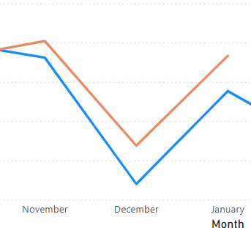

**Next steps:**

The school will continue to look for further opportunities like this to influence attendance positively. They will continue to gather pupil voice and speak with parents about what they can do to improve again, building on the growth outlined in this case study.

**Appendix Eleven –**

**Family Engagement Team**

*Background/Context*

The family engagement team (FET) are a team of centralised family support workers and pupil support officers that work with young people and families to gain an understanding of and remove barriers to participation and attendance.   
The service receives referrals from schools, and work alongside the referrer, the pupil, the family and other organisations as part of an early intervention approach aimed at those beginning to disengage. FET provide an opportunity for pupil and family to work in collaboration with a support worker and the school.

Pupil Support Officers (PSOs) deliver a short-term service working with the young person over a period of up to 12 weeks. Supporting assessment and next steps to be shared with the school. PSOs will work with pupils through an agreed "PSO Pathway" in which pupil and worker will create targets and work together to achieve them.

Family Support Workers (FSW) will work holistically with the young person and family, using a whole family approach. FSWs can work towards improving routines and structures within the household and parenting/caring approaches, while also providing guidance and signposting regarding poverty alleviation.

*The referral criteria for the service are*:

* The young person will be between stage P6 -S3.
* Young person displaying unexpected dips in attendance and/or attendance is beginning to decrease.
* Disengagement with learning becoming apparent.
* Unexplained absence contributing towards inconsistent attendance
* Attendance between 60% to 80%
* Limited or no other services involved
* Referrals without parent/carer consent will not be considered
* This is an early intervention service

*The key aims of the team are to:*

* Increase attendance
* Capture the voice of the disengaged pupil/family to enable schools to provide more targeted and personalised support needs
* Capture the well-being needs of the pupil/family using assessment tool to create priorities for targeted work.

**Appendix Twelve –**

**Senior Practitioner Social Worker (SPSW) Model – Levenmouth Academy**

Context and Role:

The role of the SPSW with Levenmouth Academy has consisted of several factors, including supporting Pupil Support/Guidance, working alongside SLT, attending education and partnership meetings, attending house meetings, being present within the school to make connections with pupils and staff, enhancing connections and collaborative working with external agencies/third sector organisations, identifying themes within the school and creating targeted groupwork opportunities as well as engaging in 1-1 work with young people

The SPSW is based within the Integrated Support Hub (ISH) which enables daily support for education staff to take place. This can take the form of both informal and formal discussions about young people or concerns that education staff have. These discussions enable education staff to make decisions/enhance plans with an added social work viewpoint.

Being present within the ISH and being available for regular conversation/support has helped to enhance confidence levels of education staff as well as an enhanced knowledge of the thresholds of services available to Levenmouth Academy.

Furthermore, being based within the ISH has enabled pupils to access support from the SPSW on a regular basis as well. More recently this has been even more successful due to the introduction of the private pods available in the ISH. This enables young people with concerns to have a safe and private space in which to converse.

Quite regularly, a role for the SPSW has been to attend education meetings that are held within Levenmouth Academy, including education reviews and meetings where education plans/Agreed Reduced Attendance plans (ARAs) are reviewed. Being present at such meetings has enhanced the SPSW’s knowledge and understanding of the education system, leading to enhanced collaboration regarding potential support that young people and families may require. Often, attending meetings has led to direct 1-1 work or groupwork being identified for young people to address barriers to education.

Attending House Meetings has been a crucial aspect of the pilot being successful within Levenmouth Academy as it has provided an opportunity for the SPSW to identify potential supports for young people, their families and for the education staff as well in terms of supporting plans moving forward. The young people identified and discussed at the house meetings often have either an internal/external service/support identified or further discussed as a potential for direct 1-1 work with the SPSW or suitability for attending targeted groupwork. In some cases, discussion within House Meetings has led to the SPSW supporting education staff with home visits to check wellbeing or discuss enhanced education plans. Discussion at House Meetings has also identified where the appropriate action/response is to make a referral to the appropriate service at the appropriate time, including a referral into social work area teams based on the severity of the need and/or risk identified.

The role of the SPSW has also been to enhance connections with services available to Levenmouth Academy, whilst increasing opportunities for collaborative working. Through identifying themes with education staff, opportunities for groupwork have materialised designed at supporting the young people that attend Levenmouth Academy further.

Supports and Interventions – Examples of impacts:

Supports include an Anxiety management Group, in collaboration with the School Nurse Team, a wellbeing group in collaboration with Clued Up and Unique physique gym, Primary 7 enhanced transition work in collaboration with Clued Up, a Fire Safety Group in collaboration with the Fire Service and Safer Communities, a wellbeing group in collaboration with Evolution Gym and Active Schools and a football and Wellbeing Group in collaboration with the other senior practitioner schools/Active Schools/Raith Rovers.

Whilst based at Levenmouth Academy the SPSW has also held a small caseload of young people that have engaged in direct 1-1 work. This has included 1-1 sessions with a young person to identify triggers for aggressive outbursts at home, in the community and at school. The young person has engaged extremely well and built a very positive relationship. The young person has reduced their aggressive outbursts significantly by focusing on anger management work, identifying constructive strategies and enhancing education plans at school. Support has been given to education staff who have worked tirelessly to support the young person creating a bespoke education plan designed at enhancing the positives and minimising opportunities for conflict. Support has been given to the family directly, but also through identifying the correct supports from external agencies for the young person and the family.

In another case a young person presented with severe anxiety. Direct work was undertaken with the young person and their parent to identify the barriers to accessing education. The young person was able to express that they had extreme levels of anxiety. As a result, several months were spent supporting the young person with anxiety management, developing strategies for managing anxiety with constructive mechanisms and then graded exposure to engaging back into education. The young person’s attendance increased to over 80% of the ARA created, and they began to engage in learning achieving National 3 and 4 qualifications.