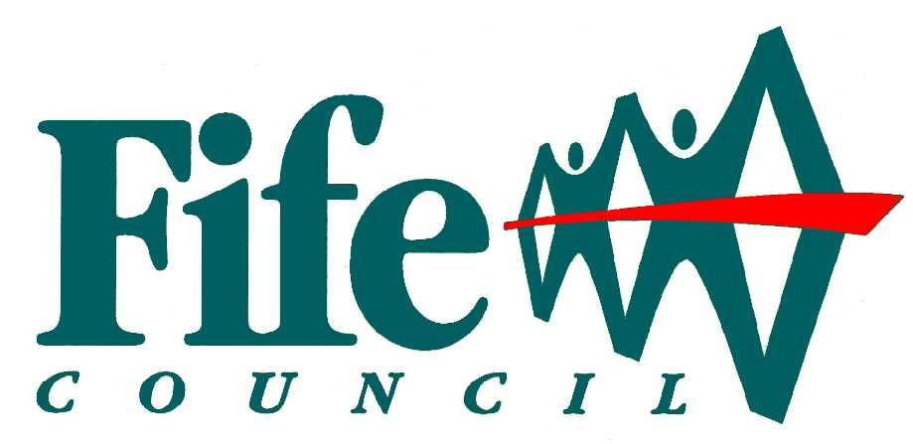


Fife Council
Social Care Services

Duty of Candour
Annual Report
1 April 2023 – 31 March 2024

Contents
Background 3
About Fife Council 3
How many incidents happened to which the duty of candour applies? 4
To what extent did Fife Council Social Work and Social Care Services follow the duty of candour procedure? 5
Information about our policies and procedures 5
What have we learned? 6
Other information 7

Background
All Health and Social Care Services in Scotland have a duty of candour. This duty applies to any care services provided by the local authority, independent providers, and the NHS. The duty of candour applies when unintended or unexpected events happen that result in death or harm as defined in the Act, the people affected understand what has happened, receive an apology, and that organisations learn how to improve in future. All services provided by the local authority that relate to the care of adults, children, or those in justice services, are subject to this duty.
An important part of this duty is that an annual report is provided by Fife Council to outline how the duty of candour is implemented in our services.

About Fife Council
Fife Council is the local authority for the Fife area of Scotland and is the third largest Scottish Council, serving a population of around 371,781. Social Work and Social Care Services are provided in the following areas:

- Adult and Older People Social Work or Social Care Services
- Children’s Social Work or Social Care Services
- Criminal Justice Social Work Services
- Early Learning and Child Care Services
- Child Care Services
- Very Sheltered Housing Services

The planning of Adult and Older People’s Social Work and Social Care Services and Very Sheltered Housing Services, and the policy decisions relating to these services, are the responsibility of the Fife Integration Joint Board. Under the Public Bodies (Joint Working) (Scotland) Act 2014, Fife Council have delegated Adult Social Work and Social Care services to the Health and Social Care Partnership. While services are operationally delivered by the Fife Health and Social Care Partnership, Fife Council still retains the responsibility to report on the Duty of Candour incidents that occur in delegated services.

Children’s Social Work Services and Justice Social Work Services are retained by Fife Council and delivered via the Communities Directorate whereas Early Learning and Childcare Services are retained by Fife Council and delivered via the Education and Children’s Services Directorate.

These services are identified collectively throughout this report as ‘Fife Council Social Work and Social Care Services”. This report describes how Fife Council Social Care Services have operated the Duty of Candour during the time between 1 April 2023 and 31 March 2024.

Our aim is to provide high quality care and support for every person who uses our services.

How many incidents happened to which the duty of candour applies?
The legislation defines a Duty of Candour incident as an unintended or unexpected incident that results in death or harm as defined in the Act and set out in the table below.

If we believe an event may trigger Duty of Candour, we must seek the views of a Registered Health Professional (RHP) to confirm that one of these “harms” has occurred as a result of the unexpected or unintended incident, rather than as a result of the individual’s illness or underlying condition.

Fife Council Social Work and Social Care Services have identified a number of routes for incidents which may trigger the duty of candour, including accidents reported by staff providing services, review of significant occurrences, incidents reported through Adult or Child Protection processes, complaints, or claims received by the Council.

All incidents relating to 2022/23 are now complete.

Between 1 April 2023 and 31 March 2024, there were two incidents where the duty of candour applies within Adult and Older People Social Work or Social Care Services. No other Fife Council Social Work or Social Care services reported any duty of candour incidents in this period.

Type of unexpected or unintended incident (not related to the natural course of someone’s illness or underlying condition) | Number of times this happened (between 1 April 2023 and 31 March 2024)
A person died | 0
A person incurred permanent lessening of bodily, sensory, motor, physiologic or intellectual functions | 0
A person’s treatment increased | 2
The structure of a person’s body changed | 0
A person’s life expectancy shortened | 0
A person’s sensory, motor, or intellectual functions was impaired for 28 days or more | 0
A person experienced pain or psychological harm for 28 days or more | 0
A person needed health treatment in order to prevent them dying | 0
A person needed health treatment in order to prevent other injuries as noted above | 0
Total | 2

In addition to following the Duty of Candour procedure, all incidents have been subject to accident reporting and investigation procedures as required by Health and Safety and other legislation.

To what extent did Fife Council Social Work and Social Care Services follow the duty of candour procedure?
When we realised the events noted above had happened, we followed the procedure in all cases. This means we informed the people affected, apologised to them, and offered to meet with them. In each case, we reviewed what happened and shared our findings with the individual and/or their family unless the individual or family had specifically stated they did not wish to receive any further information.

Each duty of candour event is reviewed by the service to understand what happened and how we might improve the care we provide in the future. The level of the review depends on the severity of the event, the potential for learning and whether any other accident reporting or investigation procedures have been followed in addition to Duty of Candour.

Any recommendations made are considered in terms of the need to develop improvement actions to meet the recommendations. These are then shared across the relevant service(s) and implemented by local management teams.

Information about our policies and procedures
Fife Council has developed a process map, guidance, and templates for staff to use if they become aware of an incident that triggers the duty of candour. These have been made available to all staff via the Fife Council intranet. Incidents are now logged on the Council’s LAGAN system.

Our process has been shared with colleagues in NHS Fife and a generic e-mail address within the NHS Fife clinical and care governance team is used by Fife Council Social Work and Social Care Services when requesting assessment of a duty of candour event by a Registered Health Professional.

All staff providing social work and care services have received briefings on the duty of candour procedure and these are now incorporated into induction processes. Identified staff are also required to complete the e-learning module. In the year 2023/24 a total of 1390 staff completed the e-learning module. This is broken down further into each Directorate as follows:

 | Education | Housing | Health & Social Care Partnership | Children & Families/ Justice Services | Others | Total
Number of staff who have undertaken training as at 31.03.2024 | 54 | 14 | 1191 | 108 | 23 | 1390

This shows a marked increase on the previous year, 2022/23 where a total number of 440 staff had undertaken the training. The latest figures will include staff refreshing their training following the work undertaken to review processes and raise awareness throughout the current year. All senior managers and those with responsibility for ensuring Duty of Candour incidents are flagged up, have completed the training, or will do so as they move into relevant posts.

We know that events that trigger the duty of candour can be distressing for staff as well as the people who receive care. We have support available for staff through our line management structure as well as through the employee counselling service and trade union representatives. Fife Health & Social Care Partnership also have the HSC094 HSCP Traumatic Incident Significant Occurrence guidance which provides Workplace Related Traumatic Incidents Guidance for staff.

What have we learned?
This is the sixth year of reporting and following the Covid 19 pandemic and the pressure that placed on service delivery across Social Work and Social Care services, we have reconstituted the Duty of Candour working group to undertake a review of the current processes and supporting training provision and the effectiveness of these and plan for improvements where necessary.

The Duty of Candour working group has met twice since the last Annual Report. The group have worked on a number of things in the background to help Directorates promote Duty of Candour to staff. A Terms of Reference is in place for the group, an intranet page has been designed and is almost ready to go live, a PowerPoint presentation was delivered to the group and this has since been shared for cascade within Directorates. The group has agreed to meet twice yearly to review progress.

An alternative approach to compiling the annual report has been undertaken, utilising a Microsoft Form which was created and shared with the working group to allow members to provide service specific information to be used in the Annual Report. It has been agreed that this approach will now be used annually so that all Directorates can contribute information for the Annual Report. The Chair of the working group has encouraged members to complete the form.

We recognise that it is vitally important to continue to raise awareness and ensure openness and transparency of communications when incidents happen.

Staff are continuing to review processes with the registered health professional and continuing to ensure sufficient background information is passed on to support the determination of whether an event meets the duty of candour criteria.

In Adult and Older People Social Work or Social Care Services, Older People Resources, the following improvements have been made:

Older People Resources will take the high-level learning points noted below and implement a learning plan across the service. This will include implementation of a three-minute briefing across Older People Resources as a way to share learning following any potential Duty of Candour event within the Service. Regular monitoring of this learning plan will be submitted via the Health and Social Care Partnership Quality Matters Assurance Group.

Risk assessments are being reviewed monthly to ensure they accurately meet the service users' needs and are updated as required

Systems are in place to ensure Unit Manager/Senior Social Care Workers are undertaking an overview/spot checks on recording in care plans

Senior Social Care Workers/staff are ensuring there is a clear and accurate account of a fall and what was happening prior to the fall

Systems are in place to ensure that Unit Manager/Senior Social Care Workers are improving audits of care plans

Risk assessments will accurately reflect the supports required to minimise falls risk

Risk Assessments are being reviewed as per guidelines and updated in the event of any change to mobility

Other information
This is the sixth year of the duty of candour being in operation and it has been a year of further learning, developing, and refining our processes to ensure the organisation is equipped to deal with duty of candour outcomes in line with the legislation.

As required, we have submitted this report to the Care Inspectorate, and we have also placed it on our website.

If you would like more information about this report, please contact us using the following details:

James Ross
Chief Social Work Officer & Head of Children & Families and Justice Services
Fife Council
Fife House
North Street
Glenrothes
KY7 5LT

