|  |  |
| --- | --- |
|  | **Application for Temporary Traffic Restrictions for Roadworks Purposes & Other Works** |

TO COMPLETE THIS FORM PLEASE CLICK OR TAP ON THE WHITE TEXT FIELD OR SELECT A CHECK BOX.

|  |  |
| --- | --- |
| **Works Details** |  |

|  |  |  |  |
| --- | --- | --- | --- |
| **ACTIVITY No:** | *(Number)* | **Company Purchase Order No.** | *(Number*) |

|  |  |
| --- | --- |
| **Description of Works – what do the works involve?** Please list all the roads affected, diversions required, etc. | (A plan showing the location of the works and any diversion route **must** be provided with this form) |
| Description of works: | * + 1. (*Describe the works that you require to carry out e.g. Installation of drainage/ carriageway reconstruction / repair water main, etc.)* |
| Roads affected: | * + 1. *(List all of the roads affected including the full extents of the sections of road you are restricting. e.g. From junction with *** to junction with ***.)* |
| Diversion route: | * + 1. *(State diversion/alternative route. For road closures, please state the exact alternative route that you intend to sign for the duration of the closure period, noting every street name or route number involved.)* |

|  |  |  |  |
| --- | --- | --- | --- |
| Temporary Restrictions | 5 days or less: | Temporary Restrictions | 6 days or more: |

|  |  |
| --- | --- |
| Type of Restriction: | Road Closure:  Other Restriction: |
| Other Restriction: | *(Waiting prohibitions / One Ways / Ban of left/right turn, etc. should be described here.)* |

|  |  |  |  |  |  |  |  |  |  |  |  |  |  |  |  |  |  |  |  |  |
| --- | --- | --- | --- | --- | --- | --- | --- | --- | --- | --- | --- | --- | --- | --- | --- | --- | --- | --- | --- | --- |
| Restriction | From | am | to | pm | Date(s): On / From | Day |  | D | / | M | / | YY | to | Day |  | D | / | M | / | YY |
| Times: |  |  |  |  |  |  |  |  |  |  |  |  |  |  |  |  |  |  |  |  |

|  |  |  |  |
| --- | --- | --- | --- |
| Are temporary restrictions to be removed overnight during works? | YES  NO | If NO: | *(Have discussions been held with affected properties/businesses?)* |
|  |  |  |  |
| Is access to be maintained for pedestrians? | YES  NO | If YES: | *(Please describe measures to be put in place.)* |
|  |  |  |  |
| a) Is access to be maintained for residents vehicles? | YES  NO | Describe Access: | *(It is essential to discuss the access provision with the Roads Network Management Unit. Residents must be able to access their properties where it is physically possible to do so. Please give a full description of how this access is to be maintained for the duration of the works. Or give reasons why and when this will not be possible.)* |
| b) Has initial consultation been carried out with affected properties and businesses? | YES  NO | Describe any issues: | *(Any issues or concerns that have been identified as part of the consultation)* |

|  |  |  |  |
| --- | --- | --- | --- |
| Is access to be maintained for emergency service vehicles? | YES  NO | Describe Access: | *(It is essential to discuss the access provision with the Roads Management Unit. Explain whether Emergency service vehicles will be able to access the restricted section of road or whether they will have to use an alternative route.)* |

|  |  |  |  |
| --- | --- | --- | --- |
| Are public transport services (bus routes) affected? | YES  NO | Details: | *(It is essential to discuss bus routes with the Roads Network Management Unit. Where buses have to be re-directed the Traffic Management team will require* ***10 extra working days’ notice*** *to carry out consultation with bus companies.)* |

|  |
| --- |
| **Council Works Only** |

|  |  |  |  |
| --- | --- | --- | --- |
| If you are applying for a TTRO as part of a Fife Council job please supply the COMIS Code for closures of 6 days or more. | *(Code)* | And Staff Diary Code | *(Code)* |

|  |
| --- |
| **Other Information** |

|  |
| --- |
| Any other information that may be relevant to your application: |
| *(This box gives you unlimited space to note any other information you feel is relevant or important to your application.)* |

|  |
| --- |
| **CONFIRM THAT ALTERNATIVE TRAFFIC MANAGEMENT HAS BEEN CONSIDERED AND DISCOUNTED BEFORE APPLYING FOR THE TTRO:** |
| *(Please provide a justification for the TTRO and the period of the order.)* |

|  |
| --- |
| **Applicant Information – Full details of the contact in your company who can answer queries regarding the restrictions.** |

|  |  |  |  |
| --- | --- | --- | --- |
| Name: | *(First name, Surname)* | Email: | *(Email address)* |

|  |  |  |  |
| --- | --- | --- | --- |
| Contact Phone No.: | *(Number)* | **24hr Public Contact Phone Number to be displayed on Public Notice:** | *(Number)* |

|  |  |
| --- | --- |
| Applying on behalf of: | *(Company/FC Team.)* |
| Address for Invoice: | *(Full postal address.)* |
| Company HQ Telephone Number | *(Please supply company headquarters telephone number.)* |
| Date of Application: | *DATE* |

|  |
| --- |
| **Checklist** |
|  |
| **TEMPORARY TRAFFIC RESTRICTION CHECKLIST** |
| Please check all relevant information has been provided along with any required attachments before the application is submitted. |

|  |  |  |
| --- | --- | --- |
| **TICK** | **ENSURE YOU HAVE PROVIDED** | **ANY ADDITIONAL INFORMATION** |
|  | ACTIVITY NUMBER AND PURCHASE ORDER NUMBER HAS BEEN PROVIDED ON THE APPLICATION. | *(Click or tap here to enter text.)* |
|  | FULL DESCRIPTION OF WORKS, ROADS AFFECTED AND ANY REQUIRED DIVERSION ROUTE. | *(Click or tap here to enter text.)* |
|  | FULL DESCRIPTION OF ANY OTHER RESTRICTIONS REQUESTED. | *(Click or tap here to enter text.)* |
|  | IF RESTRICTIONS IN PLACE FOR 24HRS, DETAILS OF DISCUSSIONS WITH AFFECTED PROPERTIES/BUSINESSES. | *(Click or tap here to enter text.)* |
|  | PEDESTRIAN ACCESS MEASURES FULLY DESCRIBED. | *(Click or tap here to enter text.)* |
|  | ACCESS FOR RESIDENTS AND EMERGENCY SERVICES VEHICLES DISCUSSED WITH ROADS NETWORK MANAGEMENT PRIOR TO APPLICATION. | *(Click or tap here to enter text.)* |
|  | ALL AFFECTED ROADS CHECKED FOR PUBLIC TRANSPORT SERVICES (BUS ROUTES) AND DISCUSSED WITH ROADS NETWORK MANAGEMENT PRIOR TO APPLICATION. | *(Click or tap here to enter text.)* |
|  | COUNCIL WORKS OVER 6 DAYS, COMIS CODE SUPPLIED. | *(Click or tap here to enter text.)* |
|  | JUSTIFICATION FOR THE TTRO AND THE PERIOD OF THE ORDER. | *(Click or tap here to enter text.)* |
|  | 24 HR PUBLIC CONTACT TELEPHONE NUMBER FOR PUBLIC NOTICE INCLUDED. | *(Click or tap here to enter text.)* |
|  | ROADWORKS REGISTER HAS BEEN CHECKED TO ENSURE THAT THERE ARE NO EXISTING TROs ON SITE FOR NO WAITING/PARKING ETC. BEFORE SUBMITTING THE FORM. | *(Click or tap here to enter text.)* |
|  | SUITABILITY OF THE DIVERSION ROUTE FOR THE PROPOSED TRAFFIC LOADING AND VOLUME HAS BEEN CHECKED. (TAKING INTO CONSIDERATION ANY BRIDGE WEIGHT OR HEIGHT RESTRICTIONS) **ANY ALTERATION TO AN AGREED DIVERSION ROUTE MUST BE APPROVED BY NETWORK MANAGEMENT.** | *(Click or tap here to enter text.)* |
|  | LOCATION MAP OF CLOSURE / RESTRICTION AND DIVERSION ROUTE HAS BEEN ATTACHED | *(Click or tap here to enter text.)* |
|  | SEPARATE TRAFFIC MANAGEMENT PLAN FOR ANY SIGNING HAS BEEN ATTACHED INCLUDING DIVERSION ROUTE. (SEE EXAMPLE) | *(Click or tap here to enter text.)* |
|  | EVIDENCE AND DATES OF CONSULTATION CARRIED OUT WITH AFFECTED BUSINESSES AND RESIDENTS. | *(Click or tap here to enter text.)* |
|  | EXPLANATION OF HOW ANY CONCERNS/ISSUES WILL BE MITIGATED. | *(Click or tap here to enter text.)* |

**THE FOLLOWING MUST BE ALSO PROVIDED AT LEAST 1 WEEK PRIOR TO THE CLOSURE:**

|  |  |  |
| --- | --- | --- |
|  | CONFIRMATION THAT ADVANCE INFORMATION SIGNS HAVE BEEN ERECTED. | *(Click or tap here to enter text.)* |

|  |
| --- |
| **Example Plan** |

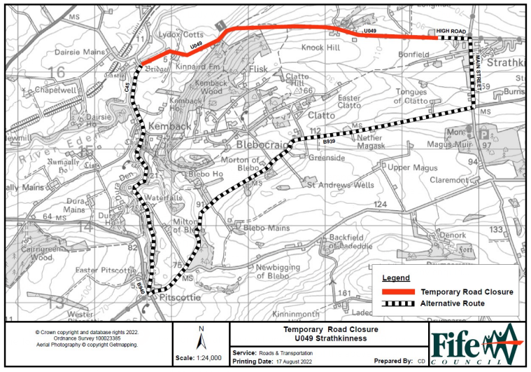

|  |
| --- |
| TIMESCALES AS DETAILED IN THE TTRO GUIDANCE SHOULD BE ADHERED TO:  **WORKS UP TO 5 DAYS –** Notice Period **15** working days**.**  **WORKS FOR 6 DAYS AND OVER –** Notice period **30** working days. |
| **WE WILL RESPOND TO YOUR APPLICATION WITHIN 14 DAYS, PLEASE DO NOT SEND EMAILS CHASING THE APPLICATION.**  Return the application form to [TempTrafficRestrictionOrder@fife.gov.uk](mailto:TempTrafficRestrictionOrder@fife.gov.uk) |

To agree appropriate restrictions and diversions contact: Roads Network Management Unit for the relevant area. It is the responsibility of the applicant to provide Diversion & Road Closure signage.

|  |  |  |
| --- | --- | --- |
|  | North Fife | South Fife |
| Tel. | 03451555555 Ext 447063 | 03451555555 Ext 480117 |
| Email. | John.Brack@fife.gov.uk | Julie.Carnell@fife.gov.uk |

The Information gathered on this form will be held by Fife Council for the purpose of determining (grant/refuse) an application under the Road Traffic Regulation Act 1984 Section 16A OR Roads (Scotland) Act 1984 Section 62. It will be shared with Statutory Undertakers and third parties using the Scottish Roadworks Register for roadwork co-ordination, etc. All collection, use and storage of personal information will be in accordance with the Data Protection Act 1998.

Further information is available on the website www.fife.gov.uk