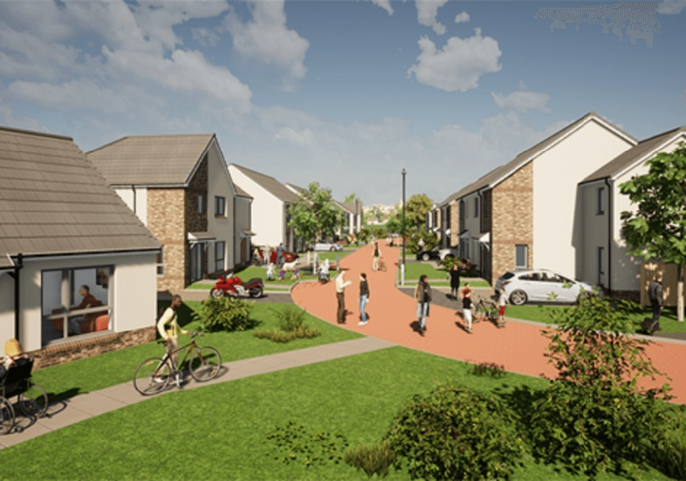**Draft High Level Housing Action Emergency Plan Appendix 1**

The priority of Fife’s Housing Emergency Plan is to ensure we meet homelessness statutory duties and legal responsibilities to tenants and other housing customers. If we are unable to provide temporary accommodation to households in need, we are breaching statutory duty and Unsuitable Accommodation Order if stays in Bed and Breakfast, hotel type accommodation are over 7 days. As a result, the Themes within the conceptual Housing Emergency Action Plan contain actions to improve our ability to provide temporary accommodation and ensure stays in B&B/hotel type accommodation are 7 days or less.

**THEME 1: Maintaining affordable housing supply**

**THEME 2: Making best use of existing properties**

**THEME 3: Enhancing housing access and prevention of homelessness**

The HEAP builds on what we are doing already, through various strategies and policies, aiming to accelerate or boost actions to mitigate the Housing Emergency. The tables give a high-level ambition of a Fife HEAP, however each area needs to be considered in detail, to be fully costed and identify the resources required. This will prioritise the immediate actions, plan and resource for medium actions and record what we need to achieve longer term. Currently there is no additional funding from Scottish or UK Government’s to support the Housing Emergency. As part of the Housing Emergency Action Plan current budgets will be reviewed, and ways to maximise any funding sources will be examined.

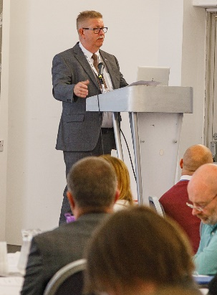The document is an initial conceptual plan based on extensive feedback from across the Council and partners since the Emergency Declaration. The Plan provides an initial baseline for further development over the summer, specifically the financial and resource aspects of the policy options. The development of a more specific performance management framework with measurable indicators is also part of the ‘Routemap’ to be reported back to Cabinet on a regular basis.

|  |  |
| --- | --- |
| April / May | Council Executive Team agreement of Governance Framework and engagement plan, Fife Partnership 21st May, 2024, Fife Housing Partnership 21st May and 26th April Workshop, Fife HEAP Summit 27th May |
| June | Cabinet Committee 6th June, further Stakeholder Engagement, Incorporation of Summit Outcomes and ongoing development of the Action Plan through the HEAP Board Council Leadership Team and Extended Council Leadership Team Engagement |
| July | Development of financial and resource plan, with associated Performance Management Framework |
| From | Finalisation of the Housing Capital Plan and Affordable Housing Programme |
| September | Production of a final Housing Emergency Action Plan |
| Onwards | Progress Report back to Cabinet |

|  |  |  |
| --- | --- | --- |
| **Theme 1: Maintaining affordable housing supply** | | |
| We need to maintain affordable housing supply in light of Scottish Government reduction in housing subsidy to support the Fife Affordable Housing Programme and options across all tenures to ensure housing needs are being met, increasing housing options and choice | | |
| **Current Challenges** | | **Impact** |
| Scottish Government reduction in the Affordable Housing Programme housing subsidy provided in 2024/25 and potentially in future years | | Reduction in the Affordable Housing Programme  New site approvals in 2024/25 reduced with impacts on properties available for let |
| HRA and landlord capital fund and revenue budget pressures within the context of inflated supply, labour and material costs | | Restricted funding capacity for acquisitions and to meet stock condition improvements |
| **Key Outcome:** *Increase Affordable Homes and Property Acquisitions* | | |
| **Improvement actions to be scoped, costed and considered with partners/stakeholders** | | |
| **2024-25** | Develop options to maintain the Affordable Housing Programme by October 2024 | |
| Develop options to finance Property Acquisitions and develop a revised approach to acquisitions by December 2024 | |
| Explore an approach to develop modular and other forms of innovative housing by working in partnership with Edinburgh & SE Scotland City Deal Regional Homes Demonstrator by March 2025 | |
| Engage with public and private sector landowners to increase the HRA landbank and support development in line with Plan4Fife by March 2025 | |
| Explore innovative housing investment and partnership models to maximise housing investment approaches | |
| **2025-27** | Increase provision of Mid-Market Rent properties as a viable housing option for homeless and housing applicants in employment | |
| Test innovative housing investment models in partnership with the Scottish Government and the FHAA | |

|  |  |  |
| --- | --- | --- |
| **Theme 2: Making best use of existing properties** | | |
| We need to make best use of existing properties, ensuring empty properties are minimised and out of use for as short a period as possible | | |
| **Current Challenges** | | **Impact** |
| 2,600 long term empty private sector homes and 60 longer term empty social rented properties | | Loss of potential housing supply, neglect and disrepair of the global housing stock |
| Barriers to accessing homes and predicted loss of homes in the PRS | | Limited housing options and affordability issues for most households |
| 1,900 statutory homeless households waiting for a permanent home | | Increased temporary accommodation provision, households waiting for longer in transitional settings, Increased costs for unsuitable accommodation |
| **Key Outcome:** *Improving engagement with the Private Sector and improved use of Public Sector properties* | | |
| **Improvement actions to be scoped, costed and considered with partners/stakeholders** | | |
| **2024-25** | Promote Allocations Policy flexibilities and enhanced Transfer Incentive Scheme linked to the review of the Housing Allocations approach by December 2024 | |
| Enhance approaches to address condensation, dampness and mould within social rented sector by October 2024 | |
| Enhance the approach and applications of SMART technology (Sensors) to support effective housing management by March 2025 | |
| Accelerate the reduction of private sector empty homes by increasing stakeholder engagement and piloting approaches through a new Long Term Empty Homes Strategy by December 2024 | |
| Develop and approach to promote preventative action to ensure owners/tenants can remain in private sector homes through enhanced equipment and adaptation services, housing support or other measures by December 2024 | |
| Improve change of tenancy timescales for all social rented sector voids with a focus on longer term voids by March 2025 | |
| **2025-27** | Re-provision harder to let retirement/specialist properties to mainstream let | |

|  |  |  |
| --- | --- | --- |
| **Theme 3: Enhancing housing access & prevention of homelessness** | | |
| We need to enhance housing access & prevention of homelessness to reduce the number of households requiring homelessness services and eradicate the use of B&B/hotel type unsuitable accommodation | | |
| **Current Challenges** | | **Impact** |
| Statutory Duty / Unsuitable Accommodation Order breaches | | Not meeting statutory duties, Increased rough sleeping and hidden homelessness |
| 2,700 homeless applications per year with increases predicted over 2 years | | More homelessness households and increased pressures on homelessness services |
| Introduction of new legislation focussed on prevention | | Increased cost of crisis led services and impact on public services |
| Potential impact of resettlement and humanitarian schemes | | Demand on properties |
| **Key Outcomes:** *Reducing homeless presentations and improving sustainment tenures* | | |
| **Improvement actions to be scoped, costed and considered with partners/stakeholders** | | |
| **2024-25** | Complete the work of the Allocations Task & Finish Group to improve the balance of supply and demand by December 2024 | |
| Embed a prevention focus into the review of the Allocations Approach and Systems Review focussing on housing options and advice by March 2025 | |
| Design and deliver a dynamic Public Engagement campaign focussed on the realities of homelessness and housing need until 2027 | |
| Develop a scheme to manage 100 Private Sector Leased properties to release properties back to the allocation pool by April 2025 | |
| Develop and upscale the Whole System Approach project to improve services to those facing household vulnerabilities and homelessness. Completing a first phase by December 2024 | |
| Create a Task Force approach to engage public bodies to promote prevention measures linked to the Housing (Scotland) Bill by September 2024 | |
| Address student homelessness pressures in St Andrews by exploring options in relation to HMOs by Oct 2024 | |
| **2025-27** | Develop a range of actions to support people to remain safely in settled accommodation | |
| Develop and test new private rented sector options in partnership with commissioned services to support tenancy sustainment | |
| Upscale the Housing First programme through collaborative commissioning | |
| Develop and implement an enhanced residential Hosting option linked to the existing Resettlement Scheme for Ukrainians | |