THE FIFE COUNCIL (MANSE ROAD AND MUIR ROAD, SPRINGFIELD) (PROHIBITION OF WAITING) ORDER 2024

On 21/03/2025 Fife Council made an Order under the Road Traffic Regulation Act 1984, the effect of which is as stated in the issue of the Fife Herald published on 11/10/2024.

A copy of the Order, which is operational from 01/04/2025 and a drawing showing the affected roads, may be inspected, without payment of fee, during normal office hours at Fife Council Headquarters, Fife House, North Street, Glenrothes and via public access pc's at your closest library. The documents will also be available online at www.fife.gov.uk/notices. Any person wishing to question the validity of the Order or of any provision contained in it on the grounds that it is not within the powers conferred by the Road Traffic Regulation Act 1984, or on the grounds that any requirement of that Act, or of any instrument made under it, has not been complied with in relation to the Order, may, within six weeks from 21/03/2025 apply to the Court of Session for the purpose.

Any queries regarding this Order should be directed to Traffic Management, Roads & Transportation Service, Bankhead Central, Bankhead Park, Glenrothes, Fife KY7 6GH or by e-mail to traffic.management@fife.gov.uk

28/03/2025

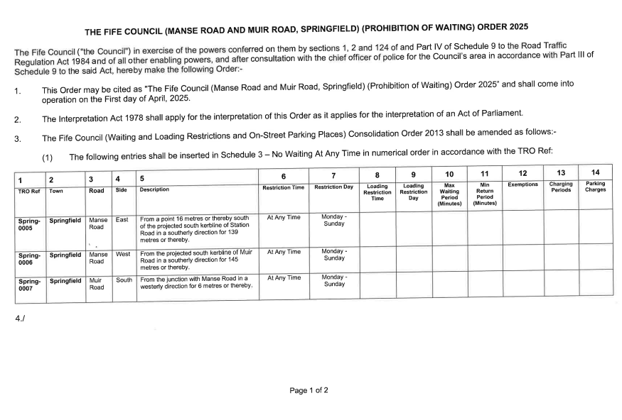
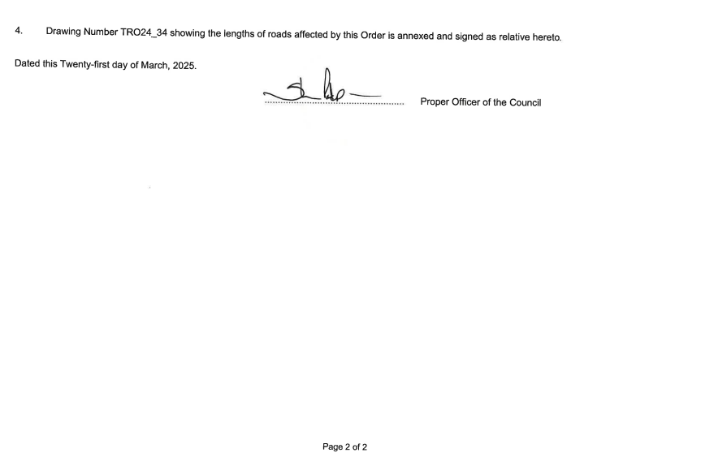

Picture caption: Plan showing no waiting restriction at Manse Road, Springfield

