**PUBLIC NOTICE**

**THE COMMUNITY EMPOWERMENT (SCOTLAND) ACT 2015**

**NOTICE OF CONSULTATION ON**

**PROPOSED DISPOSAL BY LEASE &**

**CHANGE OF USE**

**COMMON GOOD PROPERTY**

Fife Council propose to grant a lease and permit a change of use of part of a Common Good property at **106 High Street, Burntisland**. Before taking a decision, Fife Council requires to consult under Section 104 of the Community Empowerment (Scotland) Act 2015.

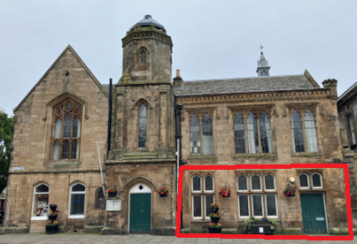 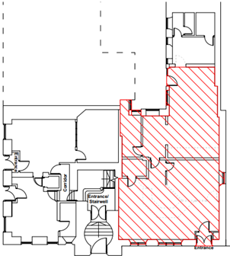

High Street

Accommodation to be let on ground floor shown above outlined and hatched red.

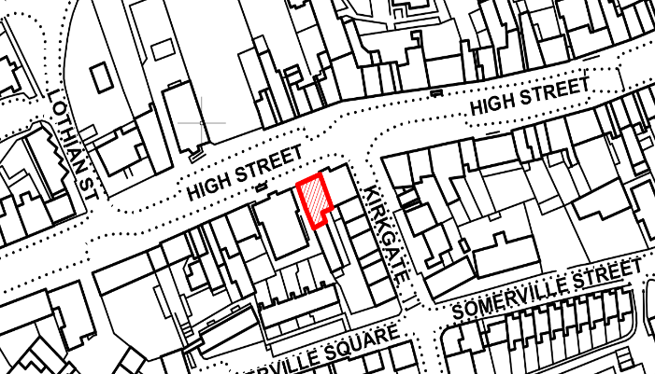

**Background**

The accommodation to be let forms part of the former Burntisland Town Hall. It was subsequently operated by Fife Council as a local office and has been unoccupied for several years. It forms part of a category B listed building.

**Disposal by lease & change of use**

It is proposed to grant a 10 year lease of the area shown above as a banking hub within class 1a of the Town and Country Planning (Use Classes) (Scotland) Order 1997 (as amended).

Banking Hubs offer easy access to face-to-face cash and banking including:

* pay in cash and cheques
* withdraw cash
* check a balance
* pay utility bills
* top up for gas and electricity
* access change-giving services (for small businesses)

**Representations**

Anyone may make representations to Fife Council in respect of this proposed disposal by lease and change of use. Representations must be in writing and include the name and address of the person making it. All representations will be published on www.fife.gov.uk at <https://www.fife.gov.uk/kb/docs/articles/council-and-democracy/land-and-property/common-good/previous-consultations>.

Representations must be received by **12th September 2024.** Representations should be sent to either [Zahida.ramzan@fife.gov.uk](mailto:Zahida.ramzan@fife.gov.uk) or [communityasset.transfer@fife.gov.uk](mailto:communityasset.transfer@fife.gov.uk)

or by post to Zahida Ramzan, Communities and Neighbourhood Service, Fife Council, Fife House, North Street, Glenrothes, KY7 5LT.

**Date of Notice: 12th July 2024**