ST2 V 2.3 (01.04.2024) Licence No.

Certificate No.
FIFE COUNCIL
CIVIC GOVERNMENT (SCOTLAND) ACT 1982
STREET TRADER’S LICENCE - APPLICATION FOR A SUBSTITUTE VEHICLE

EACH QUESTION MUST BE ANSWERED
(1) Name of Applicant
(as named on original application)
(2) Home Address (incl. Postcode)
(3) Business Hours Tel. No.
(4) E-mail address
(5) Age, Date and Place of Birth | Age | Date of Birth | Place of Birth
(6) Vehicle make, model and registration number of PRESENT vehicle.

(7) Vehicle make, model and registration number of SUBSTITUTE vehicle.

Date Signature of Applicant

Note: Following the inspection by Environmental Health, if they are not satisfied for any reason with the premises at which the goods will be stored when not being offered for sale, they shall report accordingly and their report shall be considered by the appropriate Committee of the Council along with the application.

This application must be lodged by email at misc.licensing@fife.gov.uk together with the fee of £103 for the inspection & a £30 admin fee payable by credit or debit card.

The process for paying for this is attached.

Applications will not be processed until payment has been made.

How we use your information
The information provided by you on this form will be used by Fife Council in order to process your application. It will be shared with Police Scotland (Fife Division) and may be circulated to The Scottish Fire and Rescue Service as well as the relevant Council Services for their statutory interests. Information may also be obtained from those mentioned above. Further information on how your information is used, and why, can be found here: Miscellaneous Licence | Fife Council
The Council’s Data Protection Officer can be contacted on: dataprotection@fife.gov.uk

To make a payment for your application click on Licences and permits under Make a Payment as seen below which is on the front page of our website www.fife.gov.uk

This will then take you to the page below where you click on Pay for a Licence Online

Click on the down arrow where it says Pay For below to go to the drop down menu and choose Environmental Health Fee then the reference should be ST then your surname. Enter 103.00 in the Amount to Pay then press add. Click on the down arrow where it says Pay For again and choose Miscellaneous Licence then the reference should be ST then your surname. Enter 30.00 in the Amount to Pay then press add.

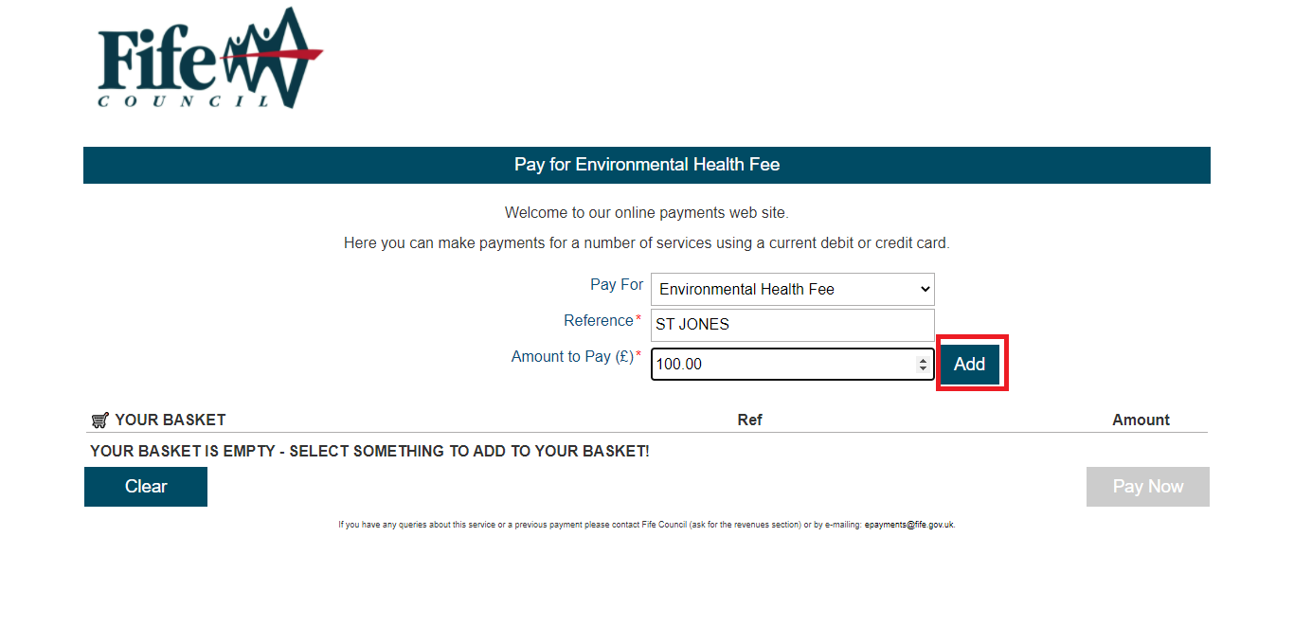

Complete your contact details then press Pay Now.

You will then be taken to the screen below where you will verify your details then press Continue

You will then be asked to add your payment details and then press Pay Now

You will then be taken to the screen below which shows you an example of your payment details

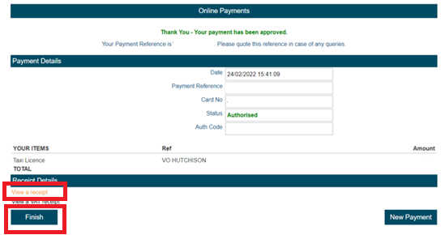

Click on View a receipt as on the above then click on finish and you will be taken to the page below

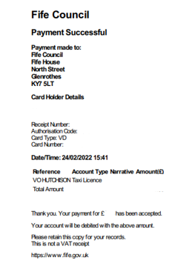
Save a copy of the above page then forward it to Misc.licensing@fife.gov.uk with your completed application.

